 | Министерство науки и высшего образования Российской Федерации  Федеральное государственное бюджетное образовательное учреждение  высшего образования  «Московский государственный технический университет  имени Н.Э. Баумана  (национальный исследовательский университет)»  (МГТУ им. Н.Э. Баумана)

Факультет «Информатика и системы управления»
Кафедра ИУ5 «Системы обработки информации и управления»

Отчет по домашнему заданию №1
по дисциплине «Методы машинного обучения»

Выполнила:
студентка группы № ИУ5-22М
Замула А.И.
подпись, дата

Проверил:
Гапанюк Ю.Е.
подпись, дата

2021 г.
Задание.
- Поиск и выбор набора данных для построения модели машинного обучения. На основе выбранного датасета строится модель машинного обучения для решения или задачи классификации, или задачи регрессии
- Для выбранного датасета на основе материалов лекций, в целях улучшения выборки, решить следующие задачи:
- Устранение пропусков в данных
- Кодировка категориальных признаков
- Нормализацию числовых признаков
- Масштабирование признаков
- Обработку выбросов для числовых признаков
- Обработку нестандартных признаков (которые не являются категориальными или числовыми)
- Отбор признаков, наиболее подходящих для построения модели
- Устранение дисбаланса классов в случае решения задачи классификации на дисбалансированной выборке
- Обучить модель и оценить метрика качества для двух выборок
- Исходная выборка, которая содержит только минимальную предобработку данных, необходимую для построения модели
- Улучшенная выборка, полученная в результате полной предобработки данных в пункте 2
- Построить модель с использованием произвольной библиотеки AutoML
- Сравнить метрики для трех полученных моделей
Текст программы и экранные формы с примерами работы программы
from google.colab import drive
drive.mount('/content/drive', force_remount=True)
path = "/content/drive/"
Mounted at /content/drive
In [ ]:
!pip3 install tensorflow==2.2
Collecting tensorflow==2.2
Downloading https://files.pythonhosted.org/packages/4c/1a/0d79814736cfecc825ab8094b39648cc9c46af7af1bae839928acb73b4dd/tensorflow-2.2.0-cp37-cp37m-manylinux2010_x86_64.whl (516.2MB)
|████████████████████████████████| 516.2MB 32kB/s
Requirement already satisfied: wheel>=0.26; python_version >= "3" in /usr/local/lib/python3.7/dist-packages (from tensorflow==2.2) (0.36.2)
Collecting gast==0.3.3
Downloading https://files.pythonhosted.org/packages/d6/84/759f5dd23fec8ba71952d97bcc7e2c9d7d63bdc582421f3cd4be845f0c98/gast-0.3.3-py2.py3-none-any.whl
Requirement already satisfied: absl-py>=0.7.0 in /usr/local/lib/python3.7/dist-packages (from tensorflow==2.2) (0.12.0)
Requirement already satisfied: protobuf>=3.8.0 in /usr/local/lib/python3.7/dist-packages (from tensorflow==2.2) (3.12.4)
Requirement already satisfied: grpcio>=1.8.6 in /usr/local/lib/python3.7/dist-packages (from tensorflow==2.2) (1.34.1)
Requirement already satisfied: termcolor>=1.1.0 in /usr/local/lib/python3.7/dist-packages (from tensorflow==2.2) (1.1.0)
Requirement already satisfied: google-pasta>=0.1.8 in /usr/local/lib/python3.7/dist-packages (from tensorflow==2.2) (0.2.0)
Requirement already satisfied: wrapt>=1.11.1 in /usr/local/lib/python3.7/dist-packages (from tensorflow==2.2) (1.12.1)
Requirement already satisfied: numpy<2.0,>=1.16.0 in /usr/local/lib/python3.7/dist-packages (from tensorflow==2.2) (1.19.5)
Requirement already satisfied: astunparse==1.6.3 in /usr/local/lib/python3.7/dist-packages (from tensorflow==2.2) (1.6.3)
Requirement already satisfied: opt-einsum>=2.3.2 in /usr/local/lib/python3.7/dist-packages (from tensorflow==2.2) (3.3.0)
Collecting tensorflow-estimator<2.3.0,>=2.2.0
Downloading https://files.pythonhosted.org/packages/a4/f5/926ae53d6a226ec0fda5208e0e581cffed895ccc89e36ba76a8e60895b78/tensorflow_estimator-2.2.0-py2.py3-none-any.whl (454kB)
|████████████████████████████████| 460kB 46.5MB/s
Requirement already satisfied: keras-preprocessing>=1.1.0 in /usr/local/lib/python3.7/dist-packages (from tensorflow==2.2) (1.1.2)
Requirement already satisfied: scipy==1.4.1; python_version >= "3" in /usr/local/lib/python3.7/dist-packages (from tensorflow==2.2) (1.4.1)
Collecting h5py<2.11.0,>=2.10.0
Downloading https://files.pythonhosted.org/packages/3f/c0/abde58b837e066bca19a3f7332d9d0493521d7dd6b48248451a9e3fe2214/h5py-2.10.0-cp37-cp37m-manylinux1_x86_64.whl (2.9MB)
|████████████████████████████████| 2.9MB 34.2MB/s
Requirement already satisfied: six>=1.12.0 in /usr/local/lib/python3.7/dist-packages (from tensorflow==2.2) (1.15.0)
Collecting tensorboard<2.3.0,>=2.2.0
Downloading https://files.pythonhosted.org/packages/1d/74/0a6fcb206dcc72a6da9a62dd81784bfdbff5fedb099982861dc2219014fb/tensorboard-2.2.2-py3-none-any.whl (3.0MB)
|████████████████████████████████| 3.0MB 17.6MB/s
Requirement already satisfied: setuptools in /usr/local/lib/python3.7/dist-packages (from protobuf>=3.8.0->tensorflow==2.2) (56.1.0)
Requirement already satisfied: werkzeug>=0.11.15 in /usr/local/lib/python3.7/dist-packages (from tensorboard<2.3.0,>=2.2.0->tensorflow==2.2) (1.0.1)
Requirement already satisfied: tensorboard-plugin-wit>=1.6.0 in /usr/local/lib/python3.7/dist-packages (from tensorboard<2.3.0,>=2.2.0->tensorflow==2.2) (1.8.0)
Requirement already satisfied: requests<3,>=2.21.0 in /usr/local/lib/python3.7/dist-packages (from tensorboard<2.3.0,>=2.2.0->tensorflow==2.2) (2.23.0)
Requirement already satisfied: google-auth-oauthlib<0.5,>=0.4.1 in /usr/local/lib/python3.7/dist-packages (from tensorboard<2.3.0,>=2.2.0->tensorflow==2.2) (0.4.4)
Requirement already satisfied: google-auth<2,>=1.6.3 in /usr/local/lib/python3.7/dist-packages (from tensorboard<2.3.0,>=2.2.0->tensorflow==2.2) (1.30.0)
Requirement already satisfied: markdown>=2.6.8 in /usr/local/lib/python3.7/dist-packages (from tensorboard<2.3.0,>=2.2.0->tensorflow==2.2) (3.3.4)
Requirement already satisfied: urllib3!=1.25.0,!=1.25.1,<1.26,>=1.21.1 in /usr/local/lib/python3.7/dist-packages (from requests<3,>=2.21.0->tensorboard<2.3.0,>=2.2.0->tensorflow==2.2) (1.24.3)
Requirement already satisfied: chardet<4,>=3.0.2 in /usr/local/lib/python3.7/dist-packages (from requests<3,>=2.21.0->tensorboard<2.3.0,>=2.2.0->tensorflow==2.2) (3.0.4)
Requirement already satisfied: certifi>=2017.4.17 in /usr/local/lib/python3.7/dist-packages (from requests<3,>=2.21.0->tensorboard<2.3.0,>=2.2.0->tensorflow==2.2) (2020.12.5)
Requirement already satisfied: idna<3,>=2.5 in /usr/local/lib/python3.7/dist-packages (from requests<3,>=2.21.0->tensorboard<2.3.0,>=2.2.0->tensorflow==2.2) (2.10)
Requirement already satisfied: requests-oauthlib>=0.7.0 in /usr/local/lib/python3.7/dist-packages (from google-auth-oauthlib<0.5,>=0.4.1->tensorboard<2.3.0,>=2.2.0->tensorflow==2.2) (1.3.0)
Requirement already satisfied: pyasn1-modules>=0.2.1 in /usr/local/lib/python3.7/dist-packages (from google-auth<2,>=1.6.3->tensorboard<2.3.0,>=2.2.0->tensorflow==2.2) (0.2.8)
Requirement already satisfied: rsa<5,>=3.1.4; python_version >= "3.6" in /usr/local/lib/python3.7/dist-packages (from google-auth<2,>=1.6.3->tensorboard<2.3.0,>=2.2.0->tensorflow==2.2) (4.7.2)
Requirement already satisfied: cachetools<5.0,>=2.0.0 in /usr/local/lib/python3.7/dist-packages (from google-auth<2,>=1.6.3->tensorboard<2.3.0,>=2.2.0->tensorflow==2.2) (4.2.2)
Requirement already satisfied: importlib-metadata; python_version < "3.8" in /usr/local/lib/python3.7/dist-packages (from markdown>=2.6.8->tensorboard<2.3.0,>=2.2.0->tensorflow==2.2) (4.0.1)
Requirement already satisfied: oauthlib>=3.0.0 in /usr/local/lib/python3.7/dist-packages (from requests-oauthlib>=0.7.0->google-auth-oauthlib<0.5,>=0.4.1->tensorboard<2.3.0,>=2.2.0->tensorflow==2.2) (3.1.0)
Requirement already satisfied: pyasn1<0.5.0,>=0.4.6 in /usr/local/lib/python3.7/dist-packages (from pyasn1-modules>=0.2.1->google-auth<2,>=1.6.3->tensorboard<2.3.0,>=2.2.0->tensorflow==2.2) (0.4.8)
Requirement already satisfied: zipp>=0.5 in /usr/local/lib/python3.7/dist-packages (from importlib-metadata; python_version < "3.8"->markdown>=2.6.8->tensorboard<2.3.0,>=2.2.0->tensorflow==2.2) (3.4.1)
Requirement already satisfied: typing-extensions>=3.6.4; python_version < "3.8" in /usr/local/lib/python3.7/dist-packages (from importlib-metadata; python_version < "3.8"->markdown>=2.6.8->tensorboard<2.3.0,>=2.2.0->tensorflow==2.2) (3.7.4.3)
Installing collected packages: gast, tensorflow-estimator, h5py, tensorboard, tensorflow
Found existing installation: gast 0.4.0
Uninstalling gast-0.4.0:
Successfully uninstalled gast-0.4.0
Found existing installation: tensorflow-estimator 2.5.0
Uninstalling tensorflow-estimator-2.5.0:
Successfully uninstalled tensorflow-estimator-2.5.0
Found existing installation: h5py 3.1.0
Uninstalling h5py-3.1.0:
Successfully uninstalled h5py-3.1.0
Found existing installation: tensorboard 2.5.0
Uninstalling tensorboard-2.5.0:
Successfully uninstalled tensorboard-2.5.0
Found existing installation: tensorflow 2.5.0
Uninstalling tensorflow-2.5.0:
Successfully uninstalled tensorflow-2.5.0
Successfully installed gast-0.3.3 h5py-2.10.0 tensorboard-2.2.2 tensorflow-2.2.0 tensorflow-estimator-2.2.0
In [ ]:
import numpy as np
import pandas as pd
import seaborn as sns
import matplotlib.pyplot as plt
from sklearn.svm import SVR
from sklearn.svm import LinearSVC
from sklearn.feature_selection import SelectFromModel
from sklearn.linear_model import Lasso
from sklearn.linear_model import LogisticRegression
from sklearn.neighbors import KNeighborsClassifier
from sklearn.neighbors import KNeighborsRegressor
from sklearn.tree import DecisionTreeClassifier
from sklearn.ensemble import RandomForestClassifier
from sklearn.ensemble import GradientBoostingClassifier
from sklearn.tree import DecisionTreeRegressor
from sklearn.ensemble import RandomForestRegressor
from sklearn.ensemble import GradientBoostingRegressor
from sklearn.metrics import mean_squared_error
from sklearn.model_selection import train_test_split
from sklearn.feature_selection import VarianceThreshold
from sklearn.feature_selection import mutual_info_classif, mutual_info_regression
from sklearn.feature_selection import SelectKBest, SelectPercentile
from sklearn.impute import SimpleImputer
from sklearn.impute import MissingIndicator
from sklearn.impute import KNNImputer
from sklearn.preprocessing import StandardScaler
from sklearn.linear_model import Lasso
from sklearn.pipeline import Pipeline
from sklearn.model_selection import GridSearchCV
from sklearn.ensemble import RandomForestRegressor
from sklearn.experimental import enable_iterative_imputer
from sklearn.impute import IterativeImputer
from sklearn.model_selection import train_test_split
from IPython.display import Image
import scipy.stats as stats
import warnings
warnings.simplefilter("ignore", UserWarning)
%matplotlib inline
sns.set(style="ticks")
In [ ]:
data = pd.read_csv(path+'/MyDrive/student-mat.csv')
data.head()
Out[ ]:
In [ ]:
data.shape
Out[ ]:
(395, 33)

Пропуски в данных
In [ ]:
data_features = list(zip(
# признаки
[i for i in data.columns],
zip(
# типы колонок
[str(i) for i in data.dtypes],
# проверим есть ли пропущенные значения
[i for i in data.isnull().sum()],
[i for i in data.nunique()]
)))
# Признаки с типом данных и количеством пропусков
data_features
Out[ ]:
[('school', ('object', 0, 2)),
('sex', ('object', 0, 2)),
('age', ('int64', 0, 8)),
('address', ('object', 0, 2)),
('famsize', ('object', 0, 2)),
('Pstatus', ('object', 0, 2)),
('Medu', ('int64', 0, 5)),
('Fedu', ('int64', 0, 5)),
('Mjob', ('object', 0, 5)),
('Fjob', ('object', 0, 5)),
('reason', ('object', 0, 4)),
('guardian', ('object', 0, 3)),
('traveltime', ('int64', 0, 4)),
('studytime', ('int64', 0, 4)),
('failures', ('int64', 0, 4)),
('schoolsup', ('object', 0, 2)),
('famsup', ('object', 0, 2)),
('paid', ('object', 0, 2)),
('activities', ('object', 0, 2)),
('nursery', ('object', 0, 2)),
('higher', ('object', 0, 2)),
('internet', ('object', 0, 2)),
('romantic', ('object', 0, 2)),
('famrel', ('int64', 0, 5)),
('freetime', ('int64', 0, 5)),
('goout', ('int64', 0, 5)),
('Dalc', ('int64', 0, 5)),
('Walc', ('int64', 0, 5)),
('health', ('int64', 0, 5)),
('absences', ('int64', 0, 34)),
('G1', ('int64', 0, 17)),
('G2', ('int64', 0, 17)),
('G3', ('int64', 0, 18))]
Пропусков в данных не обнаружено.

Кодирование категориальных признаков
In [ ]:
from sklearn.preprocessing import LabelEncoder
In [ ]:
data_encoded = data.copy()
In [ ]:
columns = ['school','sex','address','famsize','Pstatus','Mjob','Fjob','reason','guardian','schoolsup','famsup','paid','activities','nursery','higher','internet','romantic']
for column in columns:
label_encoder = LabelEncoder()
data_encoded[column] = label_encoder.fit_transform(data_encoded[column])
In [ ]:
data_encoded.head()
Out[ ]:

Нормализация числовых признаков
In [ ]:
def diagnostic_plots(df, variable):
plt.figure(figsize=(10,5))
# гистограмма
plt.subplot(1, 2, 1)
df[variable].hist(bins=30)
## Q-Q plot
plt.subplot(1, 2, 2)
stats.probplot(df[variable], dist="norm", plot=plt)
plt.show()
In [ ]:
data2 = data_encoded.copy()
data2.hist(figsize=(17,17))
plt.show()
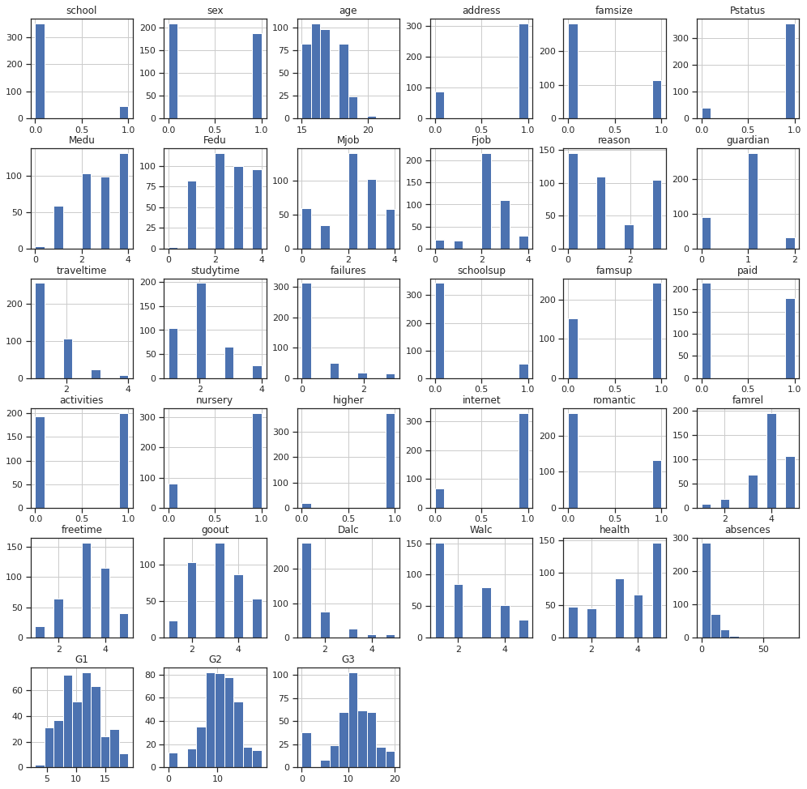
In [ ]:
diagnostic_plots(data2, 'absences')
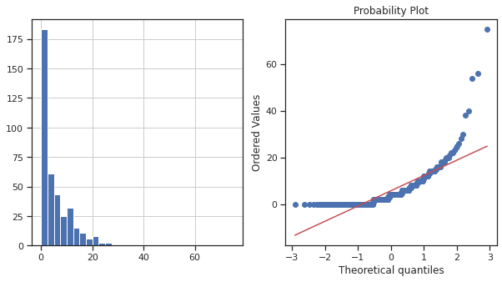
In [ ]:
data2['absences_exp1'] = data2['absences']**(0.4)
diagnostic_plots(data2, 'absences_exp1')
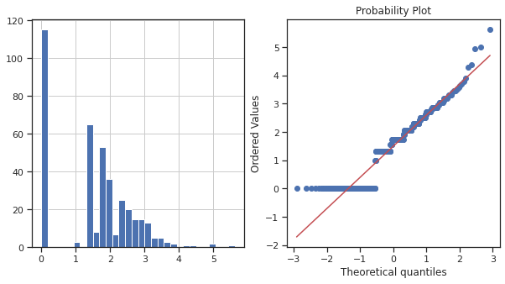
In [ ]:
data2['absences_log'] = np.log(data2['absences']+1)
diagnostic_plots(data2, 'absences_log')
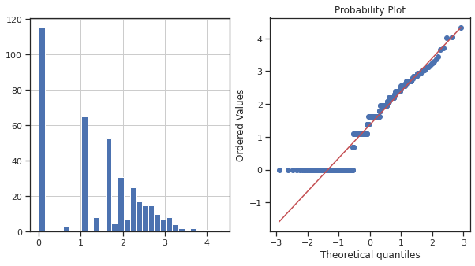
In [ ]:
data2 = data2.drop(columns=['absences'])
data2.hist(figsize=(17,17))
plt.show()
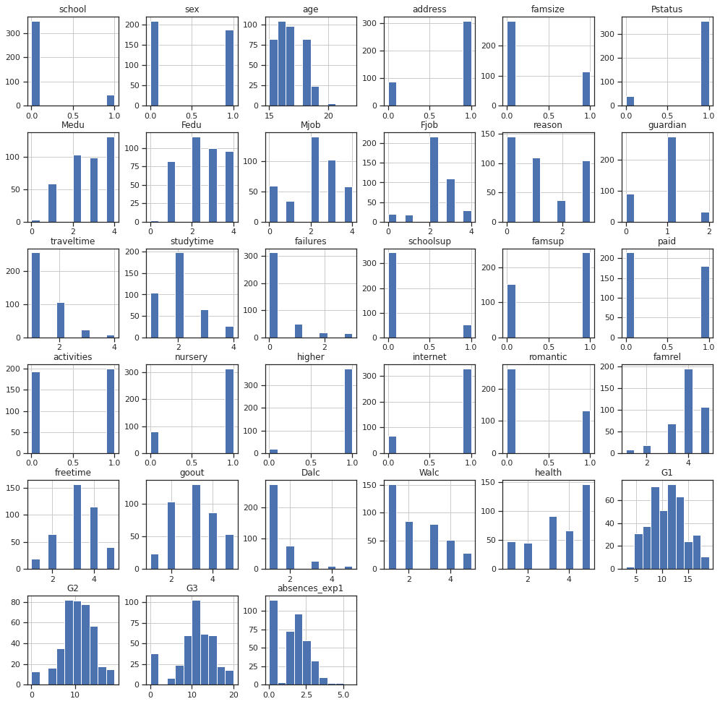
Пропустим пока нормализацию

Масштабирование признаков
In [ ]:
filtered_columns = ['age','Medu','Fedu','traveltime','studytime','failures','famrel','freetime','goout','Dalc','Walc','health','absences_exp1','G1','G2','G3']
data3 = data2[filtered_columns]
# Нужно ли масштабирование
data3.describe()
Out[ ]:
In [ ]:
# DataFrame не содержащий целевой признак
X_ALL = data3.drop('G3', axis=1)
In [ ]:
# Функция для восстановления датафрейма
# на основе масштабированных данных
def arr_to_df(arr_scaled):
res = pd.DataFrame(arr_scaled, columns=X_ALL.columns)
return res
In [ ]:
# Разделим выборку на обучающую и тестовую
X_train, X_test, y_train, y_test = train_test_split(X_ALL, data3['G3'],
test_size=0.2,
random_state=1)
# Преобразуем массивы в DataFrame
X_train_df = arr_to_df(X_train)
X_test_df = arr_to_df(X_test)

X_train_df.shape, X_test_df.shape
Out[ ]:
((316, 15), (79, 15))
In [ ]:
# Обучаем StandardScaler на всей выборке и масштабируем
cs11 = StandardScaler()
data_cs11_scaled_temp = cs11.fit_transform(X_ALL)
# формируем DataFrame на основе массива
data_cs11_scaled = arr_to_df(data_cs11_scaled_temp)
data_cs11_scaled
Out[ ]:
395 rows × 15 columns
In [ ]:
data_cs11_scaled.describe()
Out[ ]:
 | age | Medu | Fedu | traveltime | studytime | failures | famrel | freetime | goout | Dalc | Walc | health | absences_exp1 | G1 | G2
count | 3.950000e+02 | 3.950000e+02 | 3.950000e+02 | 3.950000e+02 | 3.950000e+02 | 3.950000e+02 | 3.950000e+02 | 3.950000e+02 | 3.950000e+02 | 3.950000e+02 | 3.950000e+02 | 3.950000e+02 | 3.950000e+02 | 3.950000e+02 | 3.950000e+02
mean | 1.411529e-15 | 8.432074e-18 | -1.264811e-16 | -2.203582e-16 | -2.709506e-16 | -2.599889e-16 | -1.410967e-16 | 1.028713e-16 | -2.062345e-17 | 8.769357e-17 | -3.091760e-17 | 1.169248e-16 | -1.068063e-17 | -5.424634e-17 | -1.262000e-16
std | 1.001268e+00 | 1.001268e+00 | 1.001268e+00 | 1.001268e+00 | 1.001268e+00 | 1.001268e+00 | 1.001268e+00 | 1.001268e+00 | 1.001268e+00 | 1.001268e+00 | 1.001268e+00 | 1.001268e+00 | 1.001268e+00 | 1.001268e+00 | 1.001268e+00
min | -1.330954e+00 | -2.514630e+00 | -2.320084e+00 | -6.432495e-01 | -1.235351e+00 | -4.499436e-01 | -3.287804e+00 | -2.240828e+00 | -1.896683e+00 | -5.406987e-01 | -1.003789e+00 | -1.839649e+00 | -1.307862e+00 | -2.385787e+00 | -2.851920e+00
25% | -5.462869e-01 | -6.853872e-01 | -4.798568e-01 | -6.432495e-01 | -1.235351e+00 | -4.499436e-01 | 6.219406e-02 | -2.360102e-01 | -9.972953e-01 | -5.406987e-01 | -1.003789e+00 | -3.992895e-01 | -1.307862e+00 | -8.774869e-01 | -4.562264e-01
In [ ]:
# Построение плотности распределения
def draw_kde(col_list, df1, df2, label1, label2):
fig, (ax1, ax2) = plt.subplots(
ncols=2, figsize=(12, 5))
# первый график
ax1.set_title(label1)
sns.kdeplot(data=df1[col_list], ax=ax1)
# второй график
ax2.set_title(label2)
sns.kdeplot(data=df2[col_list], ax=ax2)
plt.show()
In [ ]:
draw_kde(['absences_exp1', 'health', 'traveltime'], data3, data_cs11_scaled, 'до масштабирования', 'после масштабирования')

Работа с выбросами
In [ ]:
data4 = data_cs11_scaled
In [ ]:
x_col_list = ['age','Medu','Fedu','traveltime','studytime','failures','famrel','freetime','goout','Dalc','Walc','health','absences_exp1','G1','G2']
In [ ]:
def diagnostic_plots(df, variable, title):
fig, ax = plt.subplots(figsize=(15,10))
# гистограмма
plt.subplot(2, 2, 1)
df[variable].hist(bins=30)
## Q-Q plot
plt.subplot(2, 2, 2)
stats.probplot(df[variable], dist="norm", plot=plt)
# ящик с усами
plt.subplot(2, 2, 3)
sns.violinplot(x=df[variable])
# ящик с усами
plt.subplot(2, 2, 4)
sns.boxplot(x=df[variable])
fig.suptitle(title)
plt.show()
In [ ]:
diagnostic_plots(data4, 'age', 'age - original')
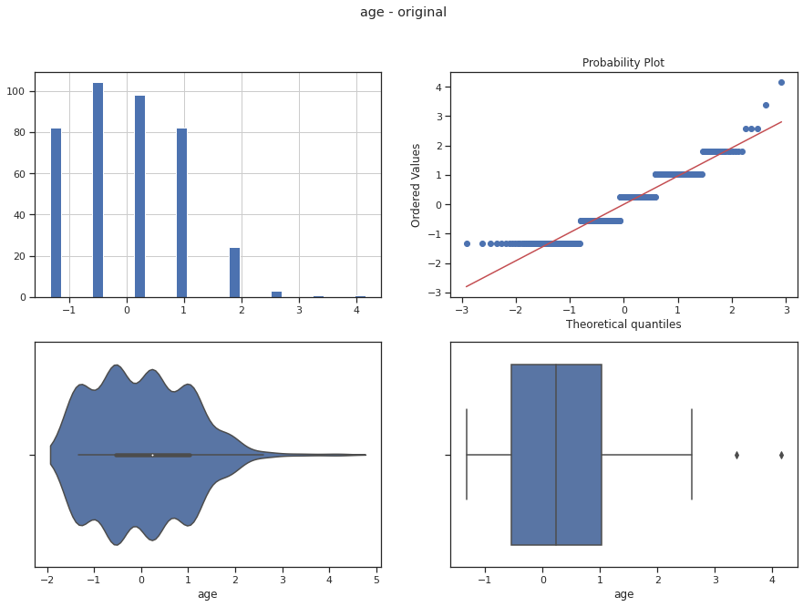
In [ ]:
# Тип вычисления верхней и нижней границы выбросов
from enum import Enum
class OutlierBoundaryType(Enum):
SIGMA = 1
QUANTILE = 2
IRQ = 3
In [ ]:
# Функция вычисления верхней и нижней границы выбросов
def get_outlier_boundaries(df, col, outlier_boundary_type: OutlierBoundaryType):
if outlier_boundary_type == OutlierBoundaryType.SIGMA:
K1 = 3
lower_boundary = df[col].mean() - (K1 * df[col].std())
upper_boundary = df[col].mean() + (K1 * df[col].std())

elif outlier_boundary_type == OutlierBoundaryType.QUANTILE:
lower_boundary = df[col].quantile(0.05)
upper_boundary = df[col].quantile(0.95)

elif outlier_boundary_type == OutlierBoundaryType.IRQ:
K2 = 1.5
IQR = df[col].quantile(0.75) - df[col].quantile(0.25)
lower_boundary = df[col].quantile(0.25) - (K2 * IQR)
upper_boundary = df[col].quantile(0.75) + (K2 * IQR)

else:
raise NameError('Unknown Outlier Boundary Type')

return lower_boundary, upper_boundary
In [ ]:
data4.shape
Out[ ]:
(395, 15)
In [ ]:
for col in x_col_list:
for obt in OutlierBoundaryType:
# Вычисление верхней и нижней границы
lower_boundary, upper_boundary = get_outlier_boundaries(data4, col, obt)
# Изменение данных
data4[col] = np.where(data4[col] > upper_boundary, upper_boundary,
np.where(data4[col] < lower_boundary, lower_boundary, data4[col]))
title = 'Поле-{}, метод-{}'.format(col, obt)
diagnostic_plots(data4, col, title)

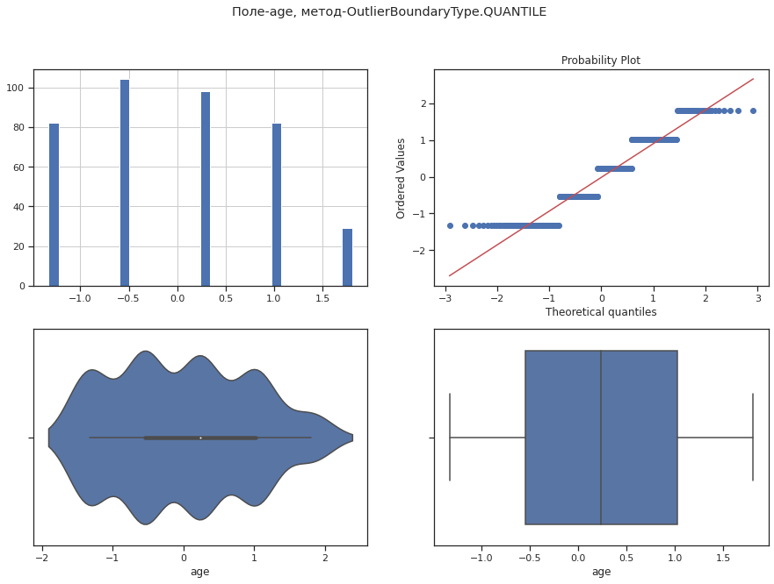
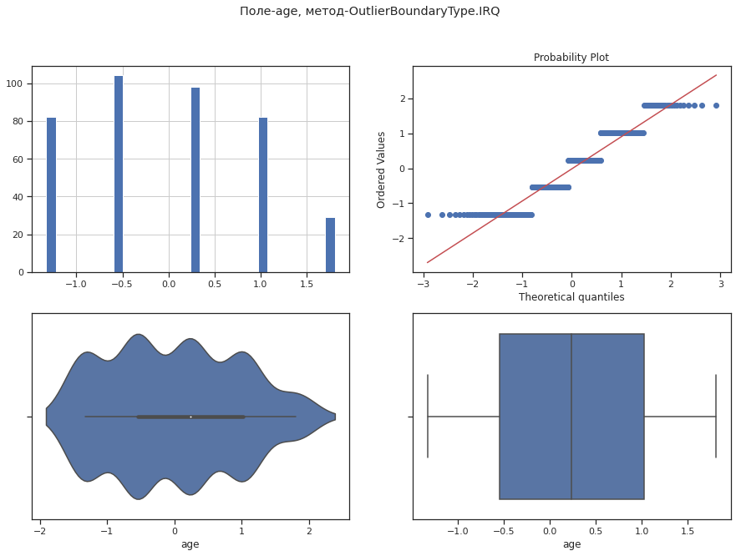

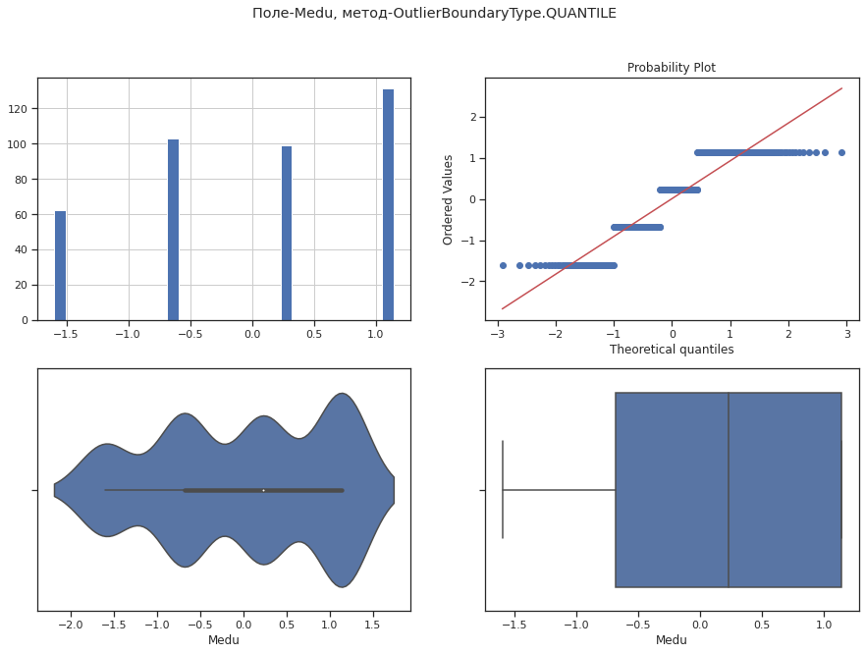

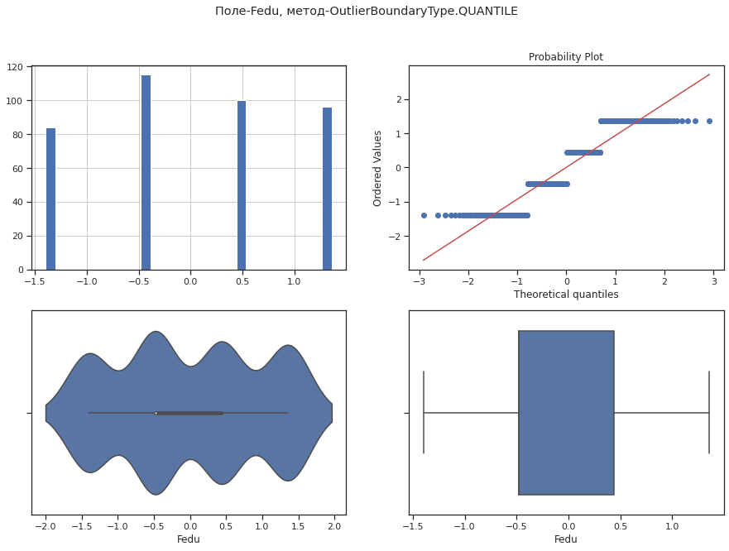
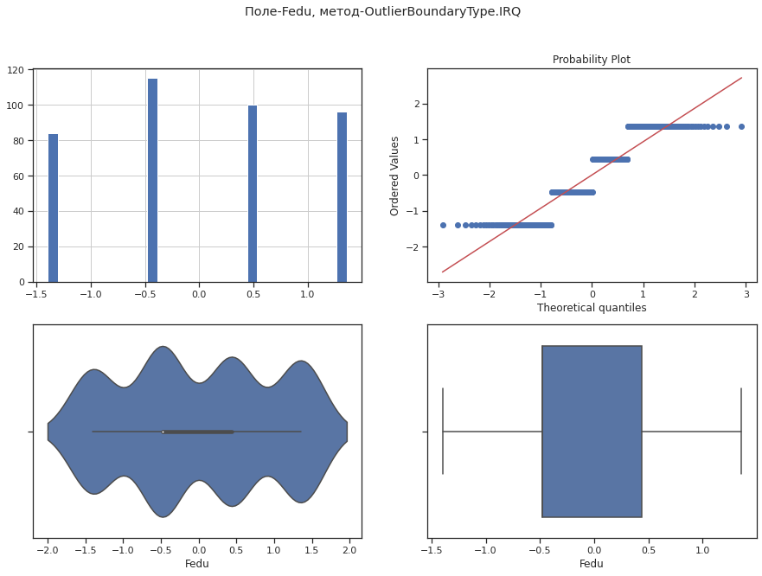

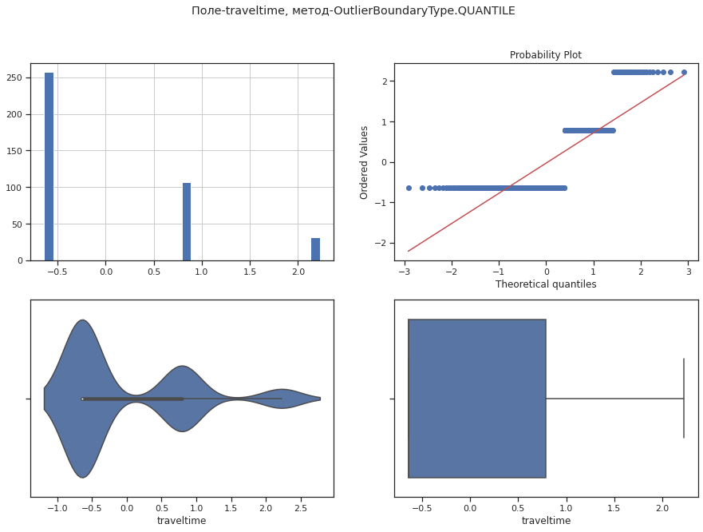
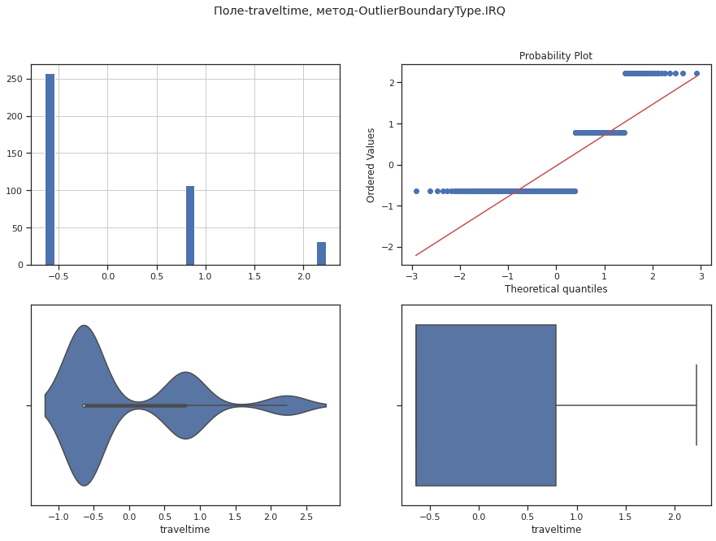
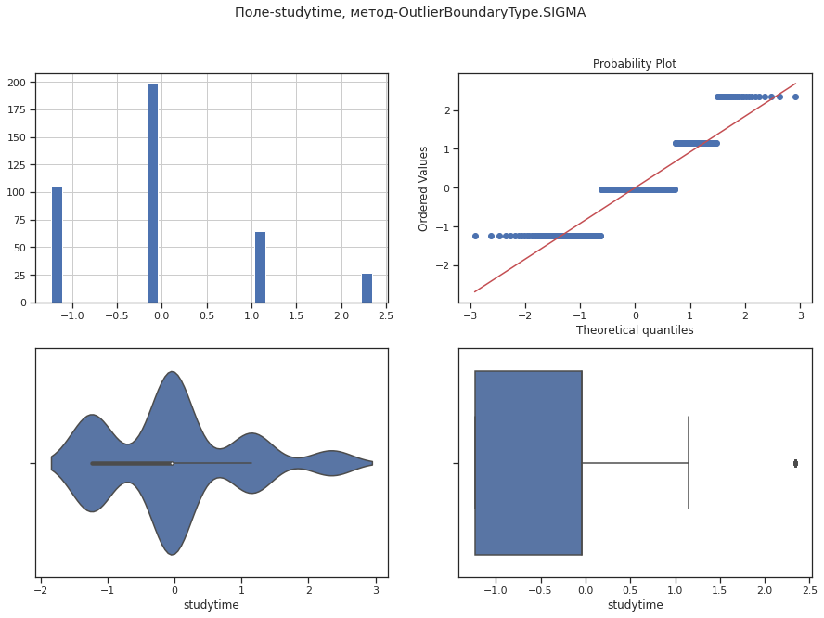

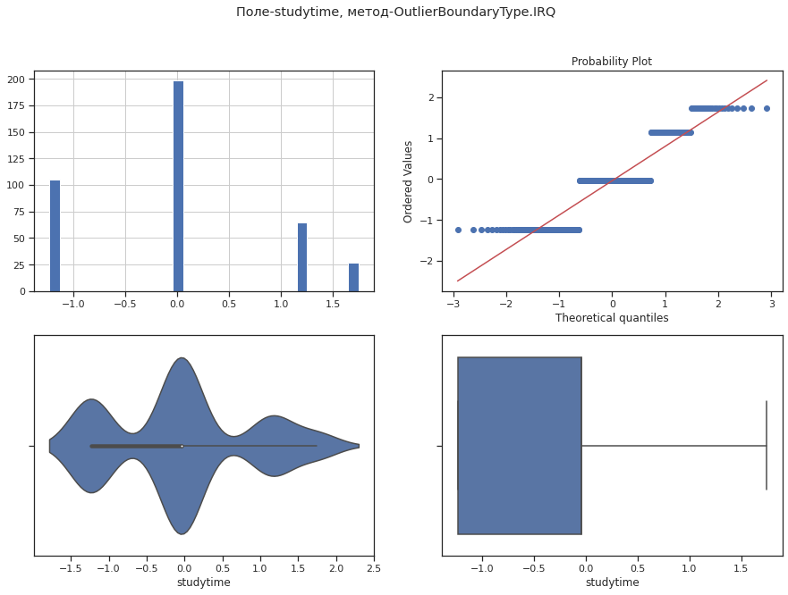

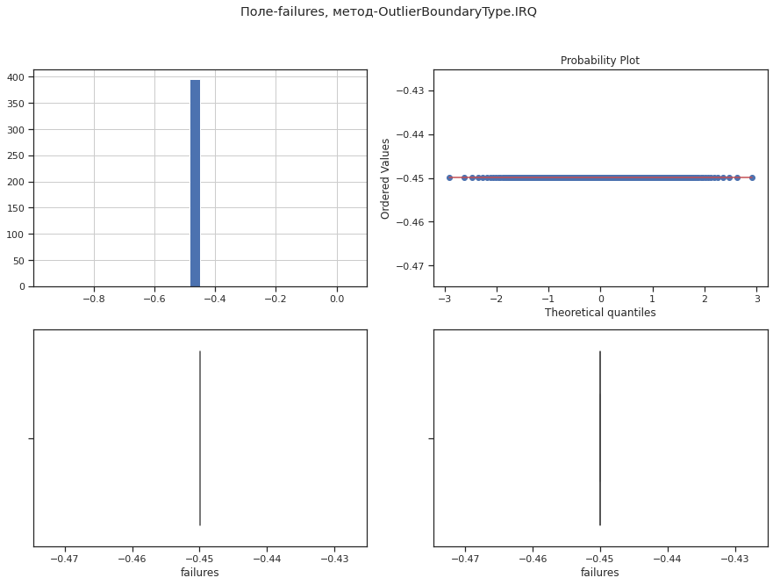
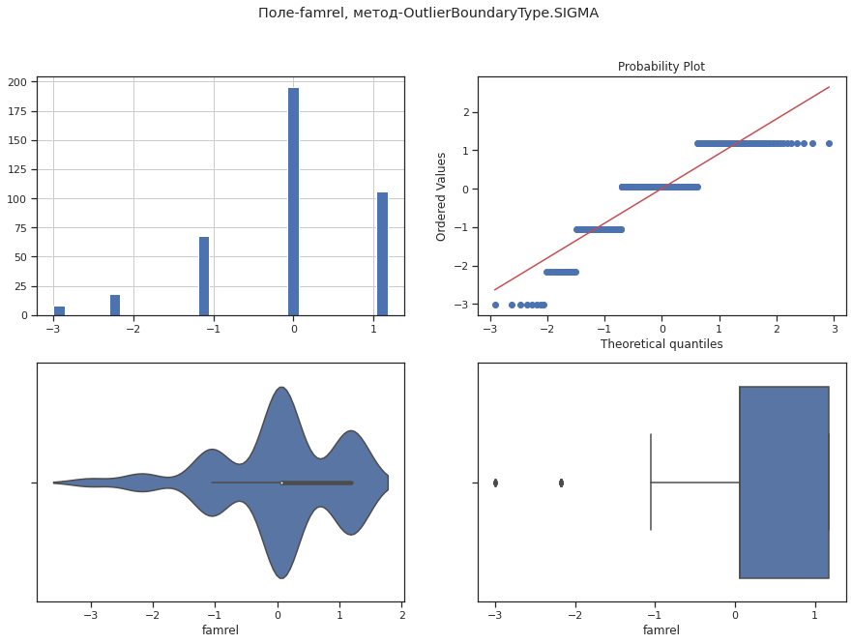

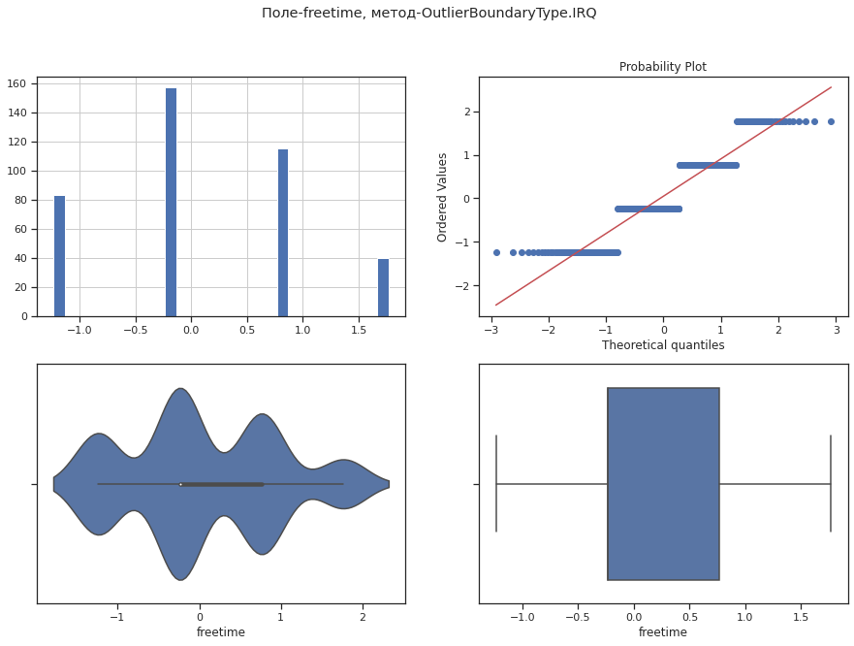

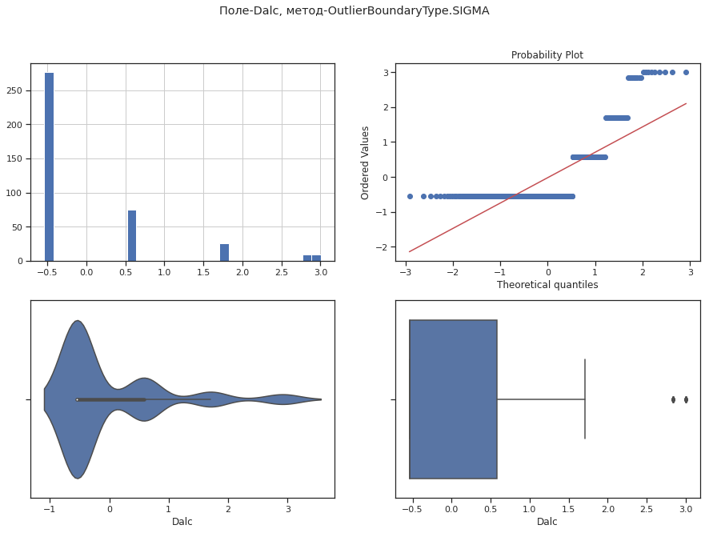
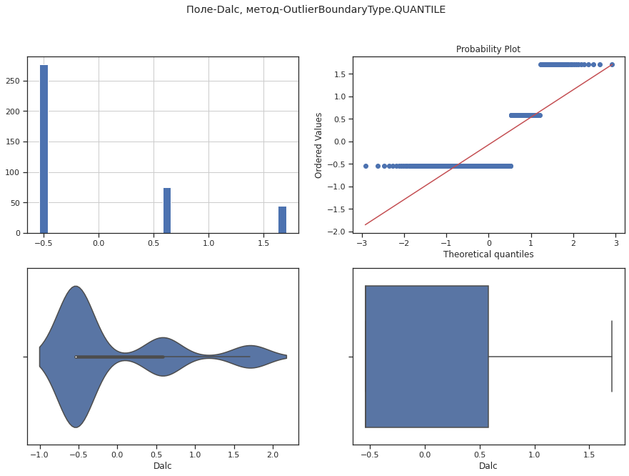

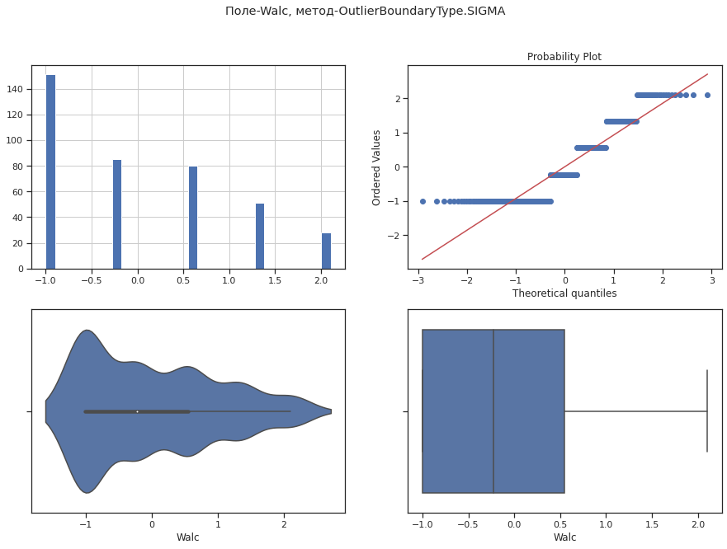
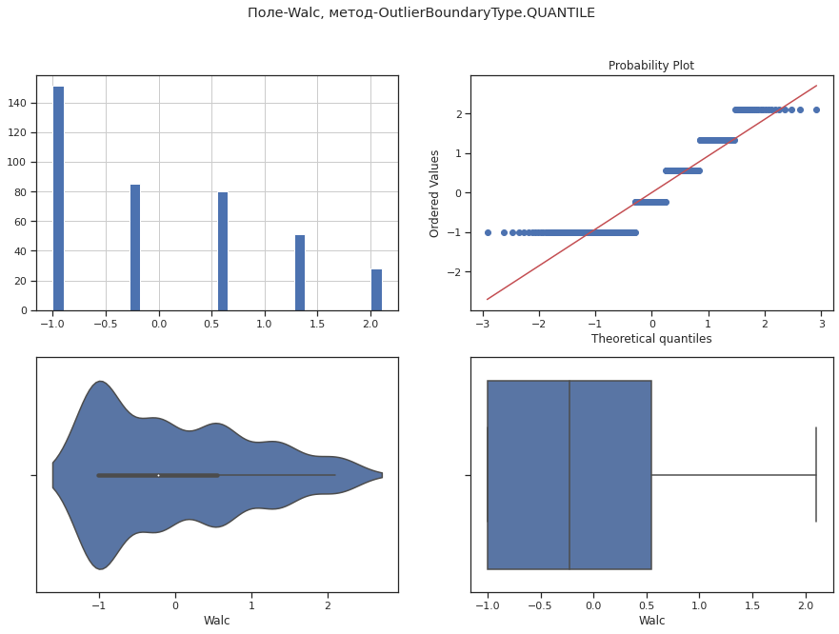

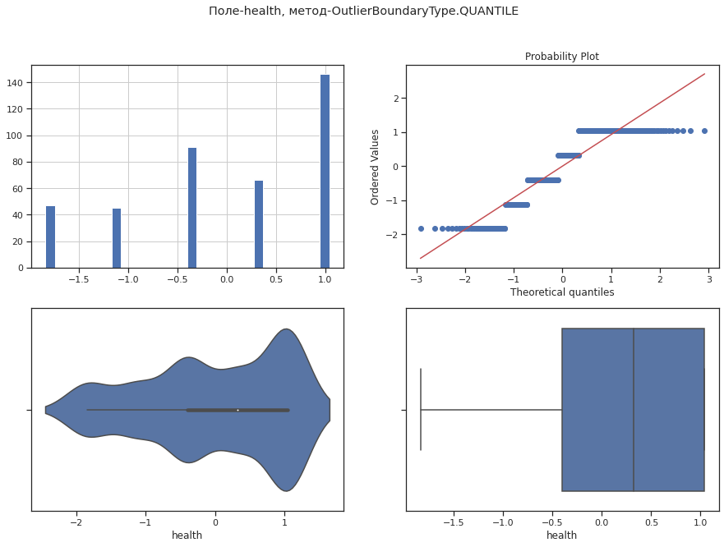
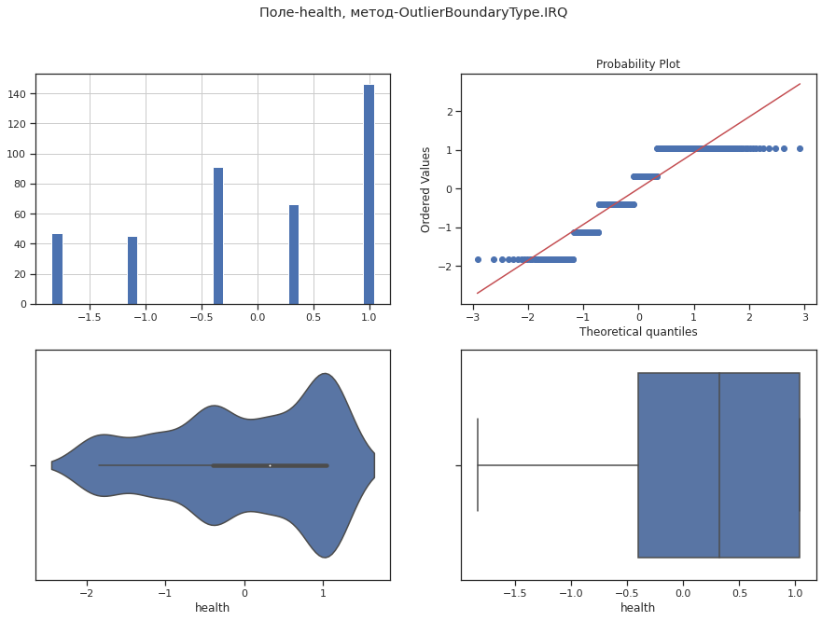
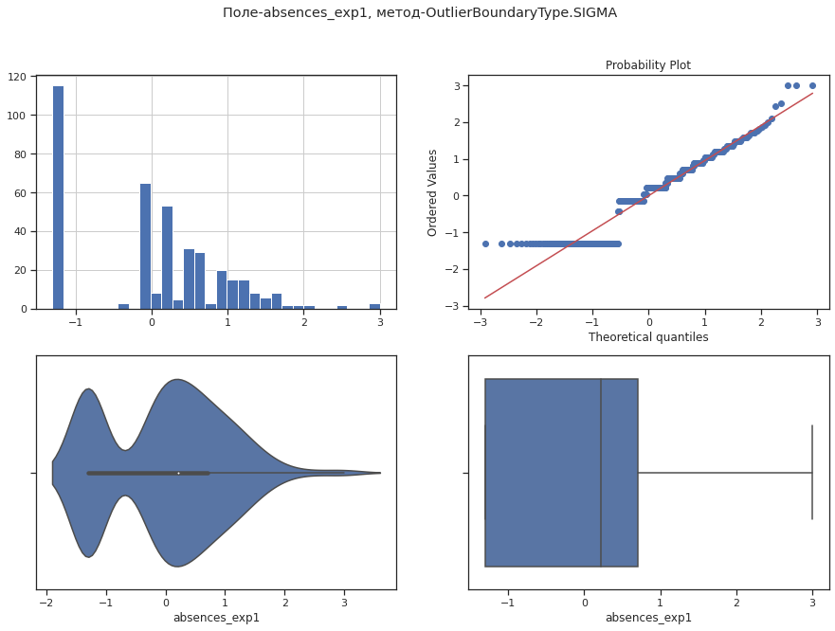
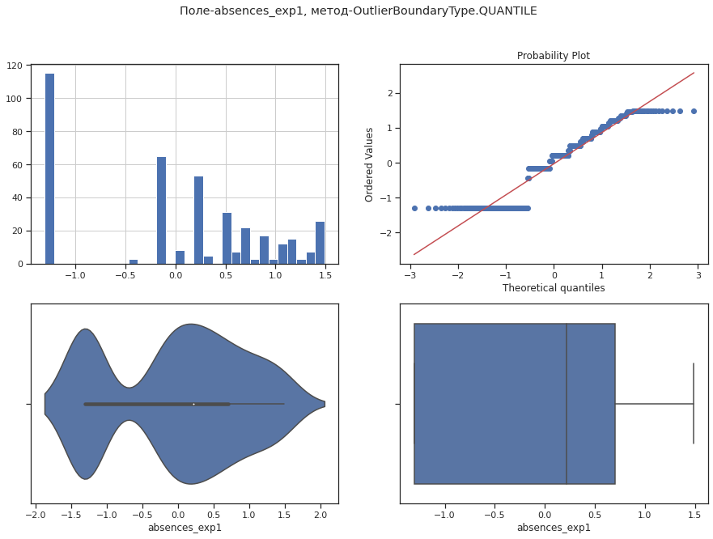

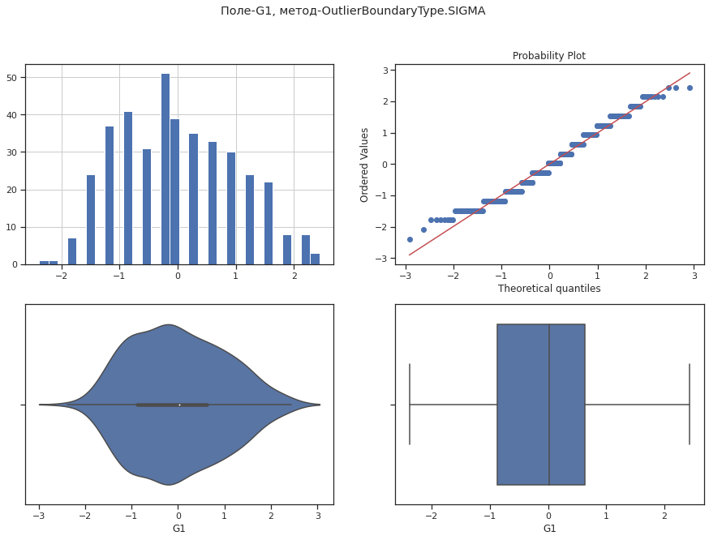

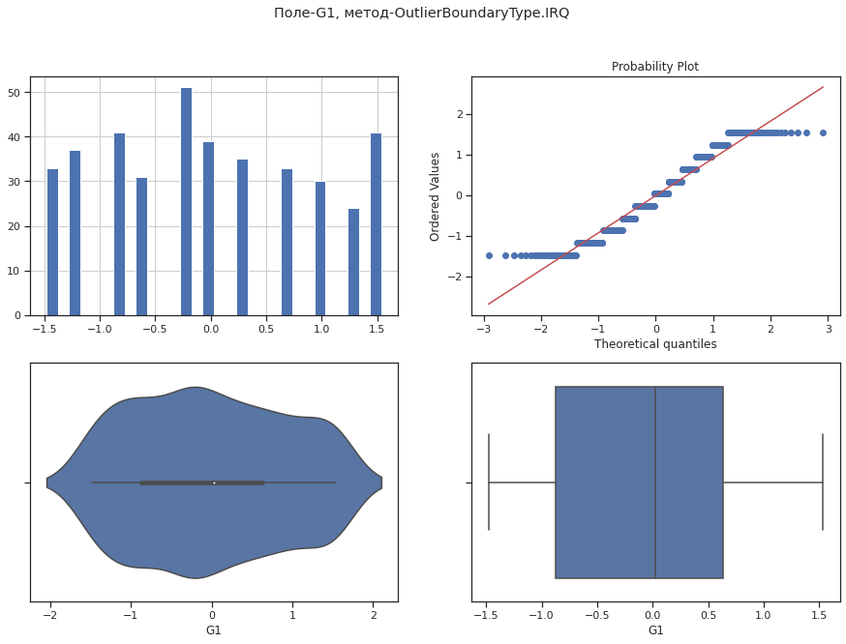
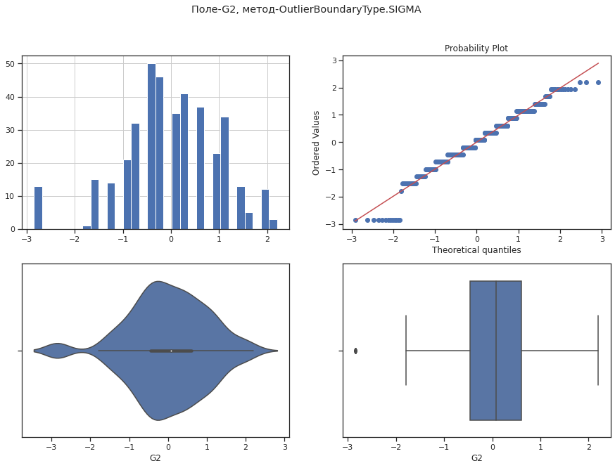
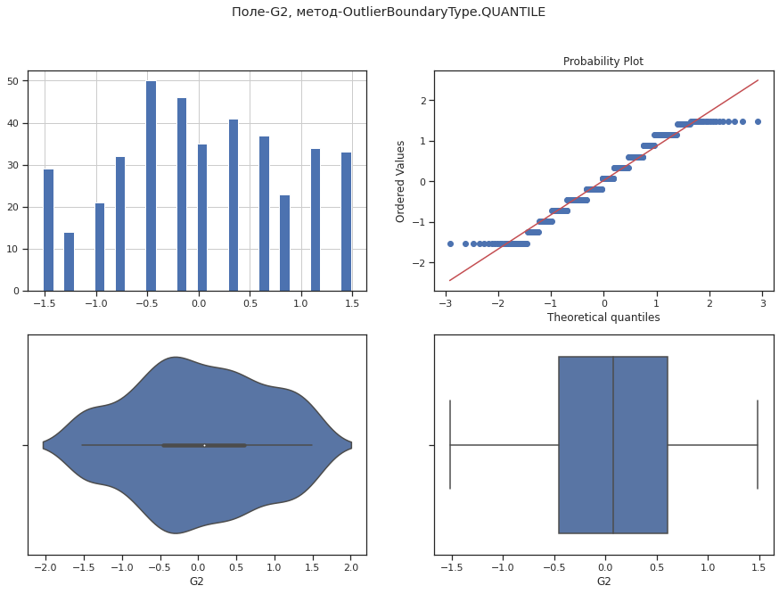
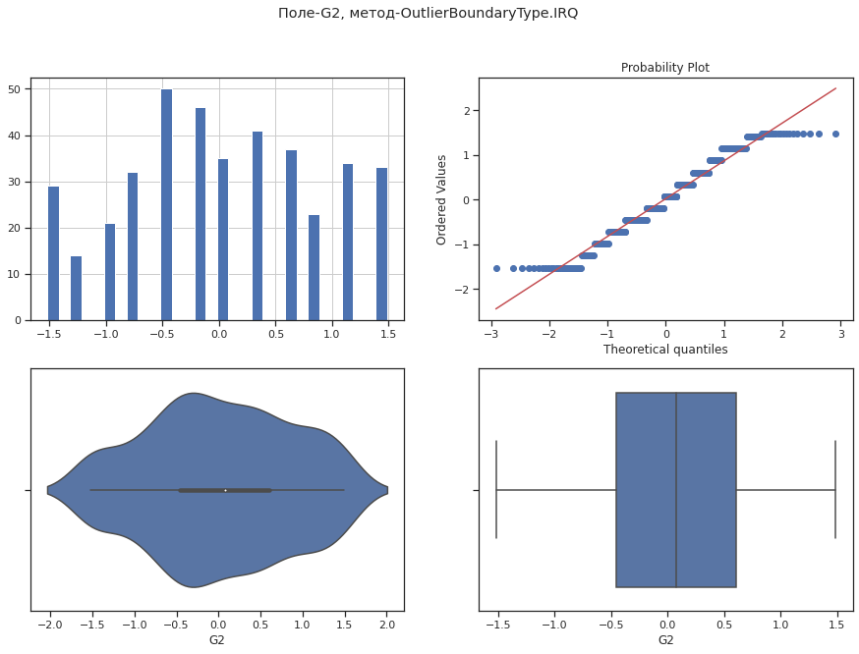
In [ ]:
diagnostic_plots(data4, 'age', 'age - new')

Соединяем
In [ ]:
data5 = data4.copy()
data5.head()
Out[ ]:
In [ ]:
data2.head()
Out[ ]:
In [ ]:
replace_columns = ['age','Medu','Fedu','traveltime','studytime','failures','famrel','freetime','goout','Dalc','Walc','health','absences_exp1','G1','G2']
for i in replace_columns:
data2[i]=data5[i]
In [ ]:
data2.head()
Out[ ]:

Обработка нестандартных признаков: не требуется

Отбор признаков
In [ ]:
data6 = data2.copy()
plt.figure(figsize=(30,30))
sns.heatmap(data6.corr(), cmap="Oranges", annot=True, linewidths=3)
Out[ ]:
<matplotlib.axes._subplots.AxesSubplot at 0x7fbd413251d0>

In [ ]:
# Формирование DataFrame с сильными корреляциями
def make_corr_df(df):
cr = data6.corr()
cr = cr.abs().unstack()
cr = cr.sort_values(ascending=False)
cr = cr[cr >= 0.8]
cr = cr[cr < 1]
cr = pd.DataFrame(cr).reset_index()
cr.columns = ['f1', 'f2', 'corr']
return cr
In [ ]:
make_corr_df(data6)
Out[ ]:
 | f1 | f2 | corr
0 | G2 | G3 | 0.895755
1 | G3 | G2 | 0.895755
2 | G1 | G2 | 0.892269
3 | G2 | G1 | 0.892269
In [ ]:
# Обнаружение групп коррелирующих признаков
def corr_groups(cr):
grouped_feature_list = []
correlated_groups = []

for feature in cr['f1'].unique():
if feature not in grouped_feature_list:
# находим коррелирующие признаки
correlated_block = cr[cr['f1'] == feature]
cur_dups = list(correlated_block['f2'].unique()) + [feature]
grouped_feature_list = grouped_feature_list + cur_dups
correlated_groups.append(cur_dups)
return correlated_groups
In [ ]:
# Группы коррелирующих признаков
corr_groups(make_corr_df(data6))
Out[ ]:
[['G3', 'G1', 'G2']]

Другой выбор признаков
In [ ]:
data_new = data2.copy()
data_new.head()
Out[ ]:
In [ ]:
# DataFrame не содержащий целевой признак
X_ALL = data_new.drop('G3', axis=1)
In [ ]:
# Функция для восстановления датафрейма
# на основе масштабированных данных
def arr_to_df(arr_scaled):
res = pd.DataFrame(arr_scaled, columns=X_ALL.columns)
return res
In [ ]:
# Разделим выборку на обучающую и тестовую
X_train, X_test, y_train, y_test = train_test_split(X_ALL, data_new['G3'],
test_size=0.2,
random_state=1)
# Преобразуем массивы в DataFrame
X_train_df = arr_to_df(X_train)
X_test_df = arr_to_df(X_test)

X_train_df.shape, X_test_df.shape
Out[ ]:
((316, 32), (79, 32))
In [ ]:
from sklearn.neighbors import KNeighborsClassifier
from mlxtend.feature_selection import ExhaustiveFeatureSelector as EFS

knn = KNeighborsClassifier(n_neighbors=3)
In [ ]:
efs1 = EFS(knn,
min_features=2,
max_features=4,
scoring='accuracy',
print_progress=True,
cv=5)

efs1 = efs1.fit(X_train, y_train, custom_feature_names=X_ALL.columns)

print('Best accuracy score: %.2f' % efs1.best_score_)
print('Best subset (indices):', efs1.best_idx_)
print('Best subset (corresponding names):', efs1.best_feature_names_)
---------------------------------------------------------------------------
KeyboardInterrupt Traceback (most recent call last)
<ipython-input-191-1df39f4e8b39> in <module>()
6 cv=5)
7
----> 8 efs1 = efs1.fit(X_train, y_train, custom_feature_names=X_ALL.columns)
9
10 print('Best accuracy score: %.2f' % efs1.best_score_)

/usr/local/lib/python3.7/dist-packages/mlxtend/feature_selection/exhaustive_feature_selector.py in fit(self, X, y, custom_feature_names, **fit_params)
270 work = enumerate(parallel(delayed(_calc_score)
271 (self, X_, y, c, **fit_params)
--> 272 for c in candidates))
273
274 try:

/usr/local/lib/python3.7/dist-packages/joblib/parallel.py in __call__(self, iterable)
1042 self._iterating = self._original_iterator is not None
1043
-> 1044 while self.dispatch_one_batch(iterator):
1045 pass
1046

/usr/local/lib/python3.7/dist-packages/joblib/parallel.py in dispatch_one_batch(self, iterator)
857 return False
858 else:
--> 859 self._dispatch(tasks)
860 return True
861

/usr/local/lib/python3.7/dist-packages/joblib/parallel.py in _dispatch(self, batch)
775 with self._lock:
776 job_idx = len(self._jobs)
--> 777 job = self._backend.apply_async(batch, callback=cb)
778 # A job can complete so quickly than its callback is
779 # called before we get here, causing self._jobs to

/usr/local/lib/python3.7/dist-packages/joblib/_parallel_backends.py in apply_async(self, func, callback)
206 def apply_async(self, func, callback=None):
207 """Schedule a func to be run"""
--> 208 result = ImmediateResult(func)
209 if callback:
210 callback(result)

/usr/local/lib/python3.7/dist-packages/joblib/_parallel_backends.py in __init__(self, batch)
570 # Don't delay the application, to avoid keeping the input
571 # arguments in memory
--> 572 self.results = batch()
573
574 def get(self):

/usr/local/lib/python3.7/dist-packages/joblib/parallel.py in __call__(self)
261 with parallel_backend(self._backend, n_jobs=self._n_jobs):
262 return [func(*args, **kwargs)
--> 263 for func, args, kwargs in self.items]
264
265 def __reduce__(self):

/usr/local/lib/python3.7/dist-packages/joblib/parallel.py in <listcomp>(.0)
261 with parallel_backend(self._backend, n_jobs=self._n_jobs):
262 return [func(*args, **kwargs)
--> 263 for func, args, kwargs in self.items]
264
265 def __reduce__(self):

/usr/local/lib/python3.7/dist-packages/mlxtend/feature_selection/exhaustive_feature_selector.py in _calc_score(selector, X, y, indices, **fit_params)
34 n_jobs=1,
35 pre_dispatch=selector.pre_dispatch,
---> 36 fit_params=fit_params)
37 else:
38 selector.est_.fit(X[:, indices], y, **fit_params)

/usr/local/lib/python3.7/dist-packages/sklearn/model_selection/_validation.py in cross_val_score(estimator, X, y, groups, scoring, cv, n_jobs, verbose, fit_params, pre_dispatch, error_score)
388 fit_params=fit_params,
389 pre_dispatch=pre_dispatch,
--> 390 error_score=error_score)
391 return cv_results['test_score']
392

/usr/local/lib/python3.7/dist-packages/sklearn/model_selection/_validation.py in cross_validate(estimator, X, y, groups, scoring, cv, n_jobs, verbose, fit_params, pre_dispatch, return_train_score, return_estimator, error_score)
234 return_times=True, return_estimator=return_estimator,
235 error_score=error_score)
--> 236 for train, test in cv.split(X, y, groups))
237
238 zipped_scores = list(zip(*scores))

/usr/local/lib/python3.7/dist-packages/joblib/parallel.py in __call__(self, iterable)
1042 self._iterating = self._original_iterator is not None
1043
-> 1044 while self.dispatch_one_batch(iterator):
1045 pass
1046

/usr/local/lib/python3.7/dist-packages/joblib/parallel.py in dispatch_one_batch(self, iterator)
857 return False
858 else:
--> 859 self._dispatch(tasks)
860 return True
861

/usr/local/lib/python3.7/dist-packages/joblib/parallel.py in _dispatch(self, batch)
775 with self._lock:
776 job_idx = len(self._jobs)
--> 777 job = self._backend.apply_async(batch, callback=cb)
778 # A job can complete so quickly than its callback is
779 # called before we get here, causing self._jobs to

/usr/local/lib/python3.7/dist-packages/joblib/_parallel_backends.py in apply_async(self, func, callback)
206 def apply_async(self, func, callback=None):
207 """Schedule a func to be run"""
--> 208 result = ImmediateResult(func)
209 if callback:
210 callback(result)

/usr/local/lib/python3.7/dist-packages/joblib/_parallel_backends.py in __init__(self, batch)
570 # Don't delay the application, to avoid keeping the input
571 # arguments in memory
--> 572 self.results = batch()
573
574 def get(self):

/usr/local/lib/python3.7/dist-packages/joblib/parallel.py in __call__(self)
261 with parallel_backend(self._backend, n_jobs=self._n_jobs):
262 return [func(*args, **kwargs)
--> 263 for func, args, kwargs in self.items]
264
265 def __reduce__(self):

/usr/local/lib/python3.7/dist-packages/joblib/parallel.py in <listcomp>(.0)
261 with parallel_backend(self._backend, n_jobs=self._n_jobs):
262 return [func(*args, **kwargs)
--> 263 for func, args, kwargs in self.items]
264
265 def __reduce__(self):

/usr/local/lib/python3.7/dist-packages/sklearn/model_selection/_validation.py in _fit_and_score(estimator, X, y, scorer, train, test, verbose, parameters, fit_params, return_train_score, return_parameters, return_n_test_samples, return_times, return_estimator, error_score)
542 else:
543 fit_time = time.time() - start_time
--> 544 test_scores = _score(estimator, X_test, y_test, scorer)
545 score_time = time.time() - start_time - fit_time
546 if return_train_score:

/usr/local/lib/python3.7/dist-packages/sklearn/model_selection/_validation.py in _score(estimator, X_test, y_test, scorer)
589 scores = scorer(estimator, X_test)
590 else:
--> 591 scores = scorer(estimator, X_test, y_test)
592
593 error_msg = ("scoring must return a number, got %s (%s) "

/usr/local/lib/python3.7/dist-packages/sklearn/metrics/_scorer.py in __call__(self, estimator, *args, **kwargs)
85 if isinstance(scorer, _BaseScorer):
86 score = scorer._score(cached_call, estimator,
---> 87 *args, **kwargs)
88 else:
89 score = scorer(estimator, *args, **kwargs)

/usr/local/lib/python3.7/dist-packages/sklearn/metrics/_scorer.py in _score(self, method_caller, estimator, X, y_true, sample_weight)
203 """
204
--> 205 y_pred = method_caller(estimator, "predict", X)
206 if sample_weight is not None:
207 return self._sign * self._score_func(y_true, y_pred,

/usr/local/lib/python3.7/dist-packages/sklearn/metrics/_scorer.py in _cached_call(cache, estimator, method, *args, **kwargs)
50 """Call estimator with method and args and kwargs."""
51 if cache is None:
---> 52 return getattr(estimator, method)(*args, **kwargs)
53
54 try:

/usr/local/lib/python3.7/dist-packages/sklearn/neighbors/_classification.py in predict(self, X)
185 for k, classes_k in enumerate(classes_):
186 if weights is None:
--> 187 mode, _ = stats.mode(_y[neigh_ind, k], axis=1)
188 else:
189 mode, _ = weighted_mode(_y[neigh_ind, k], weights, axis=1)

/usr/local/lib/python3.7/dist-packages/scipy/stats/stats.py in mode(a, axis, nan_policy)
498 counts = np.zeros(a_view.shape[:-1], dtype=np.int)
499 for ind in inds:
--> 500 modes[ind], counts[ind] = _mode1D(a_view[ind])
501 newshape = list(a.shape)
502 newshape[axis] = 1

/usr/local/lib/python3.7/dist-packages/scipy/stats/stats.py in _mode1D(a)
485
486 def _mode1D(a):
--> 487 vals, cnts = np.unique(a, return_counts=True)
488 return vals[cnts.argmax()], cnts.max()
489

<__array_function__ internals> in unique(*args, **kwargs)

/usr/local/lib/python3.7/dist-packages/numpy/lib/arraysetops.py in unique(ar, return_index, return_inverse, return_counts, axis)
259 ar = np.asanyarray(ar)
260 if axis is None:
--> 261 ret = _unique1d(ar, return_index, return_inverse, return_counts)
262 return _unpack_tuple(ret)
263

/usr/local/lib/python3.7/dist-packages/numpy/lib/arraysetops.py in _unique1d(ar, return_index, return_inverse, return_counts)
335 ret += (inv_idx,)
336 if return_counts:
--> 337 idx = np.concatenate(np.nonzero(mask) + ([mask.size],))
338 ret += (np.diff(idx),)
339 return ret

<__array_function__ internals> in nonzero(*args, **kwargs)

/usr/local/lib/python3.7/dist-packages/numpy/core/fromnumeric.py in nonzero(a)
1906
1907 """
-> 1908 return _wrapfunc(a, 'nonzero')
1909
1910

/usr/local/lib/python3.7/dist-packages/numpy/core/fromnumeric.py in _wrapfunc(obj, method, *args, **kwds)
56
57 try:
---> 58 return bound(*args, **kwds)
59 except TypeError:
60 # A TypeError occurs if the object does have such a method in its

KeyboardInterrupt:

Еще одна попытка отбора признаков
In [ ]:
datafo = data2.copy()
datafo.head()
Out[ ]:
In [ ]:
# DataFrame не содержащий целевой признак
X_ALL = datafo.drop('G3', axis=1)
In [ ]:
# Функция для восстановления датафрейма
# на основе масштабированных данных
def arr_to_df(arr_scaled):
res = pd.DataFrame(arr_scaled, columns=X_ALL.columns)
return res
In [ ]:
# Разделим выборку на обучающую и тестовую
X_train, X_test, y_train, y_test = train_test_split(X_ALL, datafo['G3'],
test_size=0.2,
random_state=1)
# Преобразуем массивы в DataFrame
X_train_df = arr_to_df(X_train)
X_test_df = arr_to_df(X_test)

X_train_df.shape, X_test_df.shape
Out[ ]:
((316, 32), (79, 32))
In [ ]:
from sklearn.linear_model import LogisticRegression
# Используем L1-регуляризацию
e_lr1 = LogisticRegression(C=1000, solver='liblinear', penalty='l1', max_iter=500, random_state=1)
e_lr1.fit(X_train, y_train)
# Коэффициенты регрессии
e_lr1.coef_
Out[ ]:
array([[-5.39523998e+00, 9.34031358e+00, 5.33611194e+00,
9.24360706e-01, 7.06166891e-01, -9.79451059e+00,
-1.53848774e+00, 6.23027389e-01, -1.30800055e+00,
-2.10485448e+00, 1.66984498e-01, -3.87929522e+00,
1.54457672e+00, 3.15366255e+00, 2.56369073e+01,
-3.30240778e+00, 4.00600960e+00, 3.49301273e+00,
2.42457322e+00, -3.51529005e+00, -1.42877606e+00,
2.20248431e-01, 3.44033783e+00, -3.38033712e+00,
-3.87678059e+00, 0.00000000e+00, 5.84769675e+00,
-4.58215577e+00, -2.73614560e+00, -8.86725563e-01,
-2.00545233e+01, -1.83465878e+01],
[ 0.00000000e+00, -7.79210611e-01, 6.88264413e-01,
0.00000000e+00, -7.68552642e-01, 0.00000000e+00,
3.50038832e+00, 0.00000000e+00, -1.17719126e+00,
-3.42006576e+00, 5.11276837e-01, 0.00000000e+00,
0.00000000e+00, 7.21955889e-02, 0.00000000e+00,
0.00000000e+00, -5.43803981e+00, 0.00000000e+00,
-2.52288896e+00, 0.00000000e+00, -2.05412334e+00,
0.00000000e+00, 0.00000000e+00, -1.00203154e+00,
0.00000000e+00, 3.93092225e-01, 0.00000000e+00,
1.26933772e+00, -2.64709302e+00, -1.66814848e+00,
-1.57541395e+00, 1.77379124e+00],
[ 0.00000000e+00, 0.00000000e+00, -3.12968652e+00,
-9.90325484e+00, 0.00000000e+00, 0.00000000e+00,
1.55953807e+00, 2.46463465e-01, -2.22389129e+00,
-1.36758873e+00, -2.61007803e+00, 0.00000000e+00,
-4.78523325e+00, 0.00000000e+00, 0.00000000e+00,
6.14986190e+00, 1.37416275e+00, -2.40194662e+00,
-4.67738912e-01, -1.27957693e+00, -6.93007304e-01,
0.00000000e+00, 0.00000000e+00, -6.50910805e-01,
3.25529879e+00, 1.15492185e+00, 0.00000000e+00,
2.95191041e+00, 2.69742337e+00, -6.57338872e+00,
-6.89955142e+00, 3.75461713e+00],
[ 0.00000000e+00, 0.00000000e+00, -2.58827755e+00,
1.41473186e-01, 1.26347490e+01, -4.70648909e+00,
2.17572899e+00, -2.72622114e+00, -5.67114459e+00,
-5.20660011e+00, 5.19518650e+00, -9.67484648e+00,
2.77143143e+00, -5.88948243e-01, 1.65695836e+01,
4.40884664e+00, 5.32042510e+00, 1.07479619e+00,
1.28807530e+01, 0.00000000e+00, -9.91449880e+00,
-1.61311187e+01, -7.13442299e+00, 5.22134841e+00,
5.78696782e-01, -2.16120033e-01, -7.28830327e+00,
-6.95034010e+00, 0.00000000e+00, -1.09324165e+01,
-2.58840982e+01, 9.41870296e+00],
[ 8.53361701e+00, -7.66434145e+00, -7.35323887e+00,
-2.20928867e+01, -6.34140081e+00, -6.42828248e+00,
1.65398420e+01, -2.03217717e+01, 9.95865057e+00,
-3.60799052e-01, -2.35803076e+00, -1.36740131e+01,
-5.57821529e+00, 7.76865886e+00, 0.00000000e+00,
0.00000000e+00, 6.86339632e+00, -1.42161453e+01,
8.97262212e+00, -1.28590923e+01, -1.28827314e+01,
-3.10440564e+01, 0.00000000e+00, 2.58424489e+00,
1.48908636e+00, 0.00000000e+00, -2.04470565e+00,
-4.48396824e-01, 5.51260822e+00, -4.09093219e+01,
-5.61812379e+00, 1.32817000e+01],
[-5.25905854e-01, 1.82881696e+00, 3.29974300e-01,
-4.77896416e-01, 2.35469779e-01, 1.18161142e+00,
-7.12219772e-01, 2.23121568e-01, 6.43424044e-02,
-2.70252359e-01, -4.18762596e-01, 1.34773767e+00,
2.07577237e-01, -8.34253012e-02, 7.80083059e+00,
8.27416358e-01, -3.35333313e-01, 2.63751299e+00,
-2.22608476e-01, 4.33861404e-01, -1.01532991e+00,
8.71033643e-01, -8.75332656e-01, -3.41260506e-02,
-1.35213802e-01, 1.23644497e-01, -6.34459600e-01,
-8.75719757e-02, -5.32695972e-02, -2.24622684e+00,
1.56611584e-01, 7.42013112e-01],
[ 7.41235012e-01, -4.02057672e-01, 6.22020774e-01,
1.26083757e+00, -1.64498125e-01, 5.28040176e-01,
4.08927388e-01, -4.58842858e-01, 3.17935574e-01,
3.36641508e-01, -1.73235909e-01, -5.05605220e-01,
-6.03519195e-01, 6.56459230e-01, 6.25654557e+00,
5.25511689e-01, 3.34148623e-01, -6.46702735e-01,
8.36608078e-01, 1.84106837e-01, -4.01613657e-01,
-6.49641686e-01, 5.67913979e-01, -1.71367425e-01,
-3.96331277e-02, -8.28383084e-04, 1.17122456e+00,
-5.88282709e-01, 4.44587411e-01, 4.68464589e-01,
-1.68500799e+00, 9.97825998e-01],
[ 5.10149355e-01, 3.54069647e-01, -3.45367795e-01,
-1.45682497e-01, 3.34304213e-02, 4.87150686e-03,
4.71216745e-01, -8.35595318e-01, -2.49576329e-01,
-1.07507028e-01, -4.94157328e-02, -5.91536646e-01,
7.78557499e-02, 3.32931274e-01, 1.76251461e+00,
-1.76436568e-01, -4.88919159e-01, 4.28904266e-01,
1.12891630e-01, 4.25015739e-01, 3.83295504e-01,
-1.95594597e-01, -9.69152440e-01, 4.96991222e-01,
1.18965125e-02, -4.31467276e-01, -3.46496369e-01,
9.49001957e-01, -4.32249419e-01, -1.17145474e+00,
2.09766763e-01, 6.08224177e-01],
[-6.77123060e-01, -7.75931613e-01, 1.01099208e-01,
4.99036769e-01, -4.11096554e-01, -6.83572281e-01,
-9.98253013e-01, 6.41252124e-01, 5.95721256e-01,
-9.55201958e-02, -1.89366614e-01, 4.95467768e-01,
7.21136091e-04, 1.33899123e-01, 7.93244277e+00,
8.87574184e-01, 9.02130538e-02, -3.38936806e-02,
-1.19580792e-01, -2.85463763e-01, 4.23897517e+00,
6.92784485e-02, 2.15308226e-01, -1.68764552e-01,
8.19507974e-02, -1.58758180e-01, 3.55640040e-04,
-9.84684529e-02, 1.07230714e-01, -6.60300635e-01,
7.82681786e-01, 4.47254886e-01],
[-4.81392361e-01, 1.04280079e+00, 4.70306180e-02,
-6.60179780e-01, 6.91882614e-01, -2.74289300e-01,
-1.70890100e-01, -7.13202819e-02, -1.72968541e-01,
5.49157660e-01, -1.68081922e-02, -5.16283753e-01,
-3.35227615e-01, 1.66225047e-01, 2.60377743e+00,
3.88154357e-01, -1.45242911e-01, -6.67127564e-03,
-4.39810127e-01, -8.98059672e-01, 1.10443706e-01,
-6.89725375e-01, 7.17955982e-01, -9.96421732e-03,
8.39805527e-02, -1.92984201e-01, -2.34873409e-02,
1.38766946e-01, 2.07671933e-01, -1.53838499e-01,
6.38848151e-01, -2.34775682e-01],
[ 1.58154634e+00, -3.22436654e-01, -4.29675097e-01,
-1.43788112e-02, -1.50706420e-01, 1.97004056e-01,
-5.52212863e-01, 7.10622099e-01, -1.38379822e-01,
-7.53285212e-01, -1.10993288e-01, 3.22212483e-01,
7.48482988e-01, -4.27715370e-01, 9.32419852e+00,
8.02850340e-02, -1.43653925e+00, 1.83377633e+00,
-1.12613714e+00, 1.38297177e+00, 4.40730232e+00,
3.71282021e-01, 6.26380757e-01, -1.31237281e-01,
-9.26604096e-02, -5.16227394e-01, 1.00630081e+00,
-2.05235782e-01, 4.78374442e-01, -5.50315209e-01,
2.57178229e+00, 1.33577664e+00],
[-2.72149545e-01, 8.03351606e-01, 1.70066147e-01,
1.31694047e+00, -1.23011316e+00, 1.44040105e+00,
-9.49303414e-02, 3.96570473e-02, -2.81923972e-01,
-9.25000325e-02, 4.78447901e-01, -4.83853854e-01,
-4.42642800e-01, 1.15599713e-02, 7.33020992e+00,
-5.50904537e-01, 5.38310146e-01, 7.22860611e-03,
-2.86401555e-01, -5.41778285e-01, 3.71647315e+00,
-1.59388691e+00, 2.85428556e-01, 2.28067582e-01,
-1.44235113e-01, 7.59928846e-01, 1.27573930e-02,
-5.51746043e-01, -4.83175852e-01, -3.94399117e-01,
1.80794286e+00, 2.71792303e-01],
[-1.14756595e+00, 6.48569154e-01, 1.33881280e-01,
1.23258774e+00, 2.16902325e-01, 2.82321679e-01,
-9.66531659e-02, 3.50207901e-01, -4.32198478e-01,
-1.28421760e-01, 5.48576317e-02, 5.73305287e-01,
3.38290483e-01, 2.77594414e-01, 6.96997979e+00,
-3.14491185e-02, -9.05208013e-01, 1.31437870e+00,
-2.02551746e-01, -1.76132755e+00, 1.49277472e+00,
9.18962455e-01, -4.36191680e-01, -7.81201570e-01,
1.64764743e-01, -1.03559587e-01, -1.06501303e+00,
-1.95626914e-01, 4.13573650e-01, 1.93817011e-01,
3.00001099e+00, -2.77609788e-01],
[-1.34164374e+02, -2.05670348e+01, 4.05665352e+01,
-2.75617542e+01, 5.12587769e+01, 2.61536464e+01,
6.04307456e+01, -6.96834298e+01, -5.48511269e+01,
2.91715201e+01, -2.23366552e+01, 2.02466928e+01,
-9.09327840e+01, -3.87089246e+01, 3.42174439e+02,
0.00000000e+00, 1.03853842e+02, -5.15463355e+01,
-8.73263081e+01, 4.04001982e+01, -2.31816620e+02,
2.28474592e+02, 6.99911894e+01, 5.90246878e+01,
3.12556509e+01, 9.01230891e+00, 3.78884446e+01,
2.94485746e+01, 5.46603246e+01, 1.24567941e+02,
1.40972020e+02, -1.12279477e+01],
[-2.63267321e+01, 0.00000000e+00, 3.09809344e+00,
-3.03357705e+00, 4.20566115e+00, 0.00000000e+00,
-8.88688949e-02, 8.82122775e+00, -4.46483986e-02,
0.00000000e+00, 1.38457100e+00, -9.58669344e-01,
2.22925480e+00, 3.60929075e+00, 0.00000000e+00,
0.00000000e+00, 8.77941640e+00, -9.28748300e+00,
0.00000000e+00, 0.00000000e+00, -1.75134376e+01,
-3.95461076e+00, 0.00000000e+00, 3.42959526e+00,
-5.43173937e-01, -2.78629339e+00, 3.62513889e+00,
0.00000000e+00, -2.48451592e+00, 7.96230542e+00,
3.96565809e+00, -4.71250915e+00],
[-7.40980029e+00, -4.56856808e+00, 3.39566600e+00,
0.00000000e+00, -3.76564626e+00, 1.11604637e+01,
4.34425450e+00, -4.64345876e-01, 2.27385874e+00,
-2.42599323e-01, -4.70057919e+00, -4.51576848e-01,
7.89718925e+00, 2.95463574e+00, 3.78821117e+01,
0.00000000e+00, 6.01890308e+00, 1.33808060e+01,
1.34909235e+01, -1.71392399e+00, -3.13417748e+01,
-1.37939308e+01, -1.20271365e+01, 1.24972231e+00,
2.09896710e+00, 0.00000000e+00, -4.89519248e+00,
-3.74730128e+00, -2.04908407e+00, 0.00000000e+00,
4.83401852e+01, 5.30217544e+00],
[ 0.00000000e+00, 0.00000000e+00, -1.43000497e+00,
-4.30785653e+00, 8.41814327e+00, -8.88966515e+00,
3.96067416e+00, 0.00000000e+00, 0.00000000e+00,
-5.56273923e-01, -1.51747545e+00, -4.11164544e-01,
0.00000000e+00, -2.93891095e-01, 0.00000000e+00,
0.00000000e+00, -7.01938593e+00, -9.93006950e-01,
-6.59178537e+00, -6.05757042e-01, -3.42924944e+00,
0.00000000e+00, -1.77932197e+00, 0.00000000e+00,
0.00000000e+00, 0.00000000e+00, -6.25154009e-01,
-3.93240729e+00, -1.79336996e+00, 3.44410582e+00,
3.16250112e+00, -4.32884298e-01],
[ 0.00000000e+00, 5.88724337e-01, 0.00000000e+00,
0.00000000e+00, 0.00000000e+00, 0.00000000e+00,
4.08094361e+00, 1.37313958e-01, -3.95147494e+00,
-1.02403445e-01, 0.00000000e+00, 0.00000000e+00,
-1.44550257e+00, 2.37481339e+00, 0.00000000e+00,
0.00000000e+00, -4.51422503e+00, -2.44994571e+00,
0.00000000e+00, 0.00000000e+00, -4.40187439e+00,
0.00000000e+00, -2.09622884e+00, 0.00000000e+00,
-2.89950723e-01, -1.72178931e+00, 0.00000000e+00,
-7.72628463e-01, -3.54917530e-01, 2.30444371e+00,
1.59642894e+00, 1.92682293e+00]])
In [ ]:
from sklearn.feature_selection import SelectFromModel
sel_e_lr1 = SelectFromModel(e_lr1)
sel_e_lr1.fit(X_train, y_train)
sel_e_lr1.get_support()
Out[ ]:
array([ True, True, True, True, True, True, True, True, True,
True, True, True, True, True, True, True, True, True,
True, True, True, True, True, True, True, True, True,
True, True, True, True, True])

Обучаем модель (минимальная обработка данных)
In [ ]:
from sklearn.model_selection import train_test_split
In [ ]:
x = data_encoded.drop([data_encoded.columns[-1]], axis=1)
x
Out[ ]:
395 rows × 32 columns
In [ ]:
def arr_to_df(arr_scaled):
res = pd.DataFrame(arr_scaled, columns=x.columns)
return res
In [ ]:
# Разделим выборку на обучающую и тестовую
X_train, X_test, y_train, y_test = train_test_split(x, data_encoded['G3'],
test_size=0.2,
random_state=1)
# Преобразуем массивы в DataFrame
X_train_df = arr_to_df(X_train)
X_test_df = arr_to_df(X_test)

X_train_df.shape, X_test_df.shape, y_train.shape, y_test.shape
Out[ ]:
((316, 32), (79, 32), (316,), (79,))
In [ ]:
class MetricLogger:

def __init__(self):
self.df = pd.DataFrame(
{'metric': pd.Series([], dtype='str'),
'alg': pd.Series([], dtype='str'),
'value': pd.Series([], dtype='float')})

def add(self, metric, alg, value):
"""
Добавление значения
"""
# Удаление значения если оно уже было ранее добавлено
self.df.drop(self.df[(self.df['metric']==metric)&(self.df['alg']==alg)].index, inplace = True)
# Добавление нового значения
temp = [{'metric':metric, 'alg':alg, 'value':value}]
self.df = self.df.append(temp, ignore_index=True)

def get_data_for_metric(self, metric, ascending=True):
"""
Формирование данных с фильтром по метрике
"""
temp_data = self.df[self.df['metric']==metric]
temp_data_2 = temp_data.sort_values(by='value', ascending=ascending)
return temp_data_2['alg'].values, temp_data_2['value'].values

def plot(self, str_header, metric, ascending=True, figsize=(5, 5)):
"""
Вывод графика
"""
array_labels, array_metric = self.get_data_for_metric(metric, ascending)
fig, ax1 = plt.subplots(figsize=figsize)
pos = np.arange(len(array_metric))
rects = ax1.barh(pos, array_metric,
align='center',
height=0.5,
tick_label=array_labels)
ax1.set_title(str_header)
for a,b in zip(pos, array_metric):
plt.text(0.5, a-0.05, str(round(b,3)), color='white')
plt.show()
In [ ]:
from sklearn.linear_model import LinearRegression
from sklearn.neighbors import KNeighborsRegressor
from sklearn.tree import DecisionTreeRegressor
from sklearn.ensemble import RandomForestRegressor
from sklearn.ensemble import GradientBoostingRegressor
from sklearn.svm import SVR
from sklearn.metrics import mean_squared_error
In [ ]:
clas_models_dict = {'LinR': LinearRegression(),
'SVR': SVR(),
'KNN_5':KNeighborsRegressor(n_neighbors=5),
'Tree':DecisionTreeRegressor(random_state=1),
'GB': GradientBoostingRegressor(random_state=1),
'RF':RandomForestRegressor(n_estimators=50, random_state=1)}
In [ ]:
X_data_dict = {'Basic': (X_train_df, X_test_df)}
In [ ]:
def test_models(clas_models_dict, X_train, X_test, y_train, y_test):

logger = MetricLogger()

for model_name, model in clas_models_dict.items():
model.fit(X_train, y_train)
y_pred = model.predict(X_test)
mse = mean_squared_error(y_test, y_pred)
logger.add(model_name, 'Basic', mse)

return logger
In [ ]:
logger = test_models(clas_models_dict, X_train_df, X_test_df, y_train, y_test)
In [ ]:
# Построим графики метрик качества модели
for model in clas_models_dict:
logger.plot('Модель: ' + model, model, figsize=(7, 1))
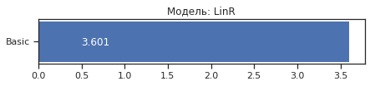
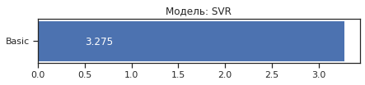
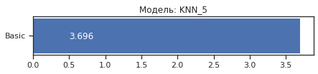

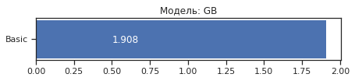
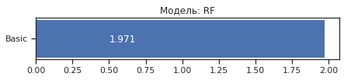

Обучаем модель (полная обработка данных)
In [ ]:
data_res = datafo.copy()
# data_res = data_res[['absences_exp1','higher','Medu','goout','romantic','age','G2','G3']]
data_res.head()
Out[ ]:
In [ ]:
x = data_res.drop([data_res.columns[-1]], axis=1)
x
Out[ ]:
395 rows × 32 columns
In [ ]:
# Разделим выборку на обучающую и тестовую
X_train, X_test, y_train, y_test = train_test_split(x, data_res['G3'],
test_size=0.2,
random_state=1)
# Преобразуем массивы в DataFrame
X_train_df = arr_to_df(X_train)
X_test_df = arr_to_df(X_test)

X_train_df.shape, X_test_df.shape, y_train.shape, y_test.shape
Out[ ]:
((316, 32), (79, 32), (316,), (79,))
In [ ]:
X_data_dict = {'Basic': (X_train_df, X_test_df)}
In [ ]:
logger = test_models(clas_models_dict, X_train_df, X_test_df, y_train, y_test)
In [ ]:
# Построим графики метрик качества модели
for model in clas_models_dict:
logger.plot('Модель: ' + model, model, figsize=(10, 10))
---------------------------------------------------------------------------
ValueError Traceback (most recent call last)
/usr/local/lib/python3.7/dist-packages/IPython/core/formatters.py in __call__(self, obj)
332 pass
333 else:
--> 334 return printer(obj)
335 # Finally look for special method names
336 method = get_real_method(obj, self.print_method)

/usr/local/lib/python3.7/dist-packages/IPython/core/pylabtools.py in <lambda>(fig)
239
240 if 'png' in formats:
--> 241 png_formatter.for_type(Figure, lambda fig: print_figure(fig, 'png', **kwargs))
242 if 'retina' in formats or 'png2x' in formats:
243 png_formatter.for_type(Figure, lambda fig: retina_figure(fig, **kwargs))

/usr/local/lib/python3.7/dist-packages/IPython/core/pylabtools.py in print_figure(fig, fmt, bbox_inches, **kwargs)
123
124 bytes_io = BytesIO()
--> 125 fig.canvas.print_figure(bytes_io, **kw)
126 data = bytes_io.getvalue()
127 if fmt == 'svg':

/usr/local/lib/python3.7/dist-packages/matplotlib/backend_bases.py in print_figure(self, filename, dpi, facecolor, edgecolor, orientation, format, bbox_inches, **kwargs)
2124 orientation=orientation,
2125 bbox_inches_restore=_bbox_inches_restore,
-> 2126 **kwargs)
2127 finally:
2128 if bbox_inches and restore_bbox:

/usr/local/lib/python3.7/dist-packages/matplotlib/backends/backend_agg.py in print_png(self, filename_or_obj, metadata, pil_kwargs, *args, **kwargs)
512 }
513
--> 514 FigureCanvasAgg.draw(self)
515 if pil_kwargs is not None:
516 from PIL import Image

/usr/local/lib/python3.7/dist-packages/matplotlib/backends/backend_agg.py in draw(self)
386 Draw the figure using the renderer.
387 """
--> 388 self.renderer = self.get_renderer(cleared=True)
389 # Acquire a lock on the shared font cache.
390 with RendererAgg.lock, \

/usr/local/lib/python3.7/dist-packages/matplotlib/backends/backend_agg.py in get_renderer(self, cleared)
402 and getattr(self, "_lastKey", None) == key)
403 if not reuse_renderer:
--> 404 self.renderer = RendererAgg(w, h, self.figure.dpi)
405 self._lastKey = key
406 elif cleared:

/usr/local/lib/python3.7/dist-packages/matplotlib/backends/backend_agg.py in __init__(self, width, height, dpi)
90 self.width = width
91 self.height = height
---> 92 self._renderer = _RendererAgg(int(width), int(height), dpi)
93 self._filter_renderers = []
94

ValueError: Image size of -537773730x606 pixels is too large. It must be less than 2^16 in each direction.
<Figure size 720x720 with 1 Axes>
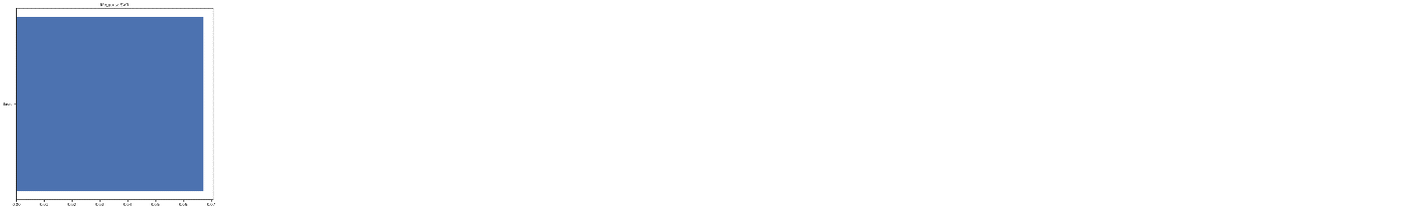
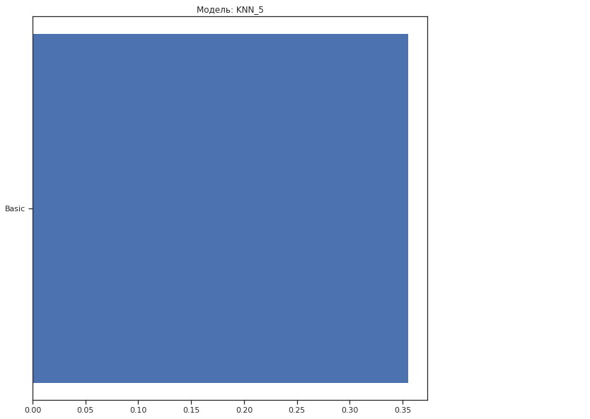

---------------------------------------------------------------------------
ValueError Traceback (most recent call last)
/usr/local/lib/python3.7/dist-packages/IPython/core/formatters.py in __call__(self, obj)
332 pass
333 else:
--> 334 return printer(obj)
335 # Finally look for special method names
336 method = get_real_method(obj, self.print_method)

/usr/local/lib/python3.7/dist-packages/IPython/core/pylabtools.py in <lambda>(fig)
239
240 if 'png' in formats:
--> 241 png_formatter.for_type(Figure, lambda fig: print_figure(fig, 'png', **kwargs))
242 if 'retina' in formats or 'png2x' in formats:
243 png_formatter.for_type(Figure, lambda fig: retina_figure(fig, **kwargs))

/usr/local/lib/python3.7/dist-packages/IPython/core/pylabtools.py in print_figure(fig, fmt, bbox_inches, **kwargs)
123
124 bytes_io = BytesIO()
--> 125 fig.canvas.print_figure(bytes_io, **kw)
126 data = bytes_io.getvalue()
127 if fmt == 'svg':

/usr/local/lib/python3.7/dist-packages/matplotlib/backend_bases.py in print_figure(self, filename, dpi, facecolor, edgecolor, orientation, format, bbox_inches, **kwargs)
2124 orientation=orientation,
2125 bbox_inches_restore=_bbox_inches_restore,
-> 2126 **kwargs)
2127 finally:
2128 if bbox_inches and restore_bbox:

/usr/local/lib/python3.7/dist-packages/matplotlib/backends/backend_agg.py in print_png(self, filename_or_obj, metadata, pil_kwargs, *args, **kwargs)
512 }
513
--> 514 FigureCanvasAgg.draw(self)
515 if pil_kwargs is not None:
516 from PIL import Image

/usr/local/lib/python3.7/dist-packages/matplotlib/backends/backend_agg.py in draw(self)
386 Draw the figure using the renderer.
387 """
--> 388 self.renderer = self.get_renderer(cleared=True)
389 # Acquire a lock on the shared font cache.
390 with RendererAgg.lock, \

/usr/local/lib/python3.7/dist-packages/matplotlib/backends/backend_agg.py in get_renderer(self, cleared)
402 and getattr(self, "_lastKey", None) == key)
403 if not reuse_renderer:
--> 404 self.renderer = RendererAgg(w, h, self.figure.dpi)
405 self._lastKey = key
406 elif cleared:

/usr/local/lib/python3.7/dist-packages/matplotlib/backends/backend_agg.py in __init__(self, width, height, dpi)
90 self.width = width
91 self.height = height
---> 92 self._renderer = _RendererAgg(int(width), int(height), dpi)
93 self._filter_renderers = []
94

ValueError: Image size of 35627669x606 pixels is too large. It must be less than 2^16 in each direction.
<Figure size 720x720 with 1 Axes>
---------------------------------------------------------------------------
ValueError Traceback (most recent call last)
/usr/local/lib/python3.7/dist-packages/IPython/core/formatters.py in __call__(self, obj)
332 pass
333 else:
--> 334 return printer(obj)
335 # Finally look for special method names
336 method = get_real_method(obj, self.print_method)

/usr/local/lib/python3.7/dist-packages/IPython/core/pylabtools.py in <lambda>(fig)
239
240 if 'png' in formats:
--> 241 png_formatter.for_type(Figure, lambda fig: print_figure(fig, 'png', **kwargs))
242 if 'retina' in formats or 'png2x' in formats:
243 png_formatter.for_type(Figure, lambda fig: retina_figure(fig, **kwargs))

/usr/local/lib/python3.7/dist-packages/IPython/core/pylabtools.py in print_figure(fig, fmt, bbox_inches, **kwargs)
123
124 bytes_io = BytesIO()
--> 125 fig.canvas.print_figure(bytes_io, **kw)
126 data = bytes_io.getvalue()
127 if fmt == 'svg':

/usr/local/lib/python3.7/dist-packages/matplotlib/backend_bases.py in print_figure(self, filename, dpi, facecolor, edgecolor, orientation, format, bbox_inches, **kwargs)
2124 orientation=orientation,
2125 bbox_inches_restore=_bbox_inches_restore,
-> 2126 **kwargs)
2127 finally:
2128 if bbox_inches and restore_bbox:

/usr/local/lib/python3.7/dist-packages/matplotlib/backends/backend_agg.py in print_png(self, filename_or_obj, metadata, pil_kwargs, *args, **kwargs)
512 }
513
--> 514 FigureCanvasAgg.draw(self)
515 if pil_kwargs is not None:
516 from PIL import Image

/usr/local/lib/python3.7/dist-packages/matplotlib/backends/backend_agg.py in draw(self)
386 Draw the figure using the renderer.
387 """
--> 388 self.renderer = self.get_renderer(cleared=True)
389 # Acquire a lock on the shared font cache.
390 with RendererAgg.lock, \

/usr/local/lib/python3.7/dist-packages/matplotlib/backends/backend_agg.py in get_renderer(self, cleared)
402 and getattr(self, "_lastKey", None) == key)
403 if not reuse_renderer:
--> 404 self.renderer = RendererAgg(w, h, self.figure.dpi)
405 self._lastKey = key
406 elif cleared:

/usr/local/lib/python3.7/dist-packages/matplotlib/backends/backend_agg.py in __init__(self, width, height, dpi)
90 self.width = width
91 self.height = height
---> 92 self._renderer = _RendererAgg(int(width), int(height), dpi)
93 self._filter_renderers = []
94

ValueError: Image size of 165634x593 pixels is too large. It must be less than 2^16 in each direction.
<Figure size 720x720 with 1 Axes>

AUTOML
In [ ]:
!pip3 install mljar-supervised
!pip3 install delayed
Collecting mljar-supervised
Downloading https://files.pythonhosted.org/packages/0b/45/878916fb350cbe08ce51365305c54ee56e253c7be7979e0a18d753ebbb84/mljar-supervised-0.10.4.tar.gz (109kB)
|████████████████████████████████| 112kB 3.9MB/s
Collecting numpy>=1.20.0
Downloading https://files.pythonhosted.org/packages/a5/42/560d269f604d3e186a57c21a363e77e199358d054884e61b73e405dd217c/numpy-1.20.3-cp37-cp37m-manylinux_2_12_x86_64.manylinux2010_x86_64.whl (15.3MB)
|████████████████████████████████| 15.3MB 278kB/s
Collecting pandas==1.2.0
Downloading https://files.pythonhosted.org/packages/ff/bd/fb376f9fbad92b9a6efdbb30ff32c80f3cba1368689309cbb5566364af5c/pandas-1.2.0-cp37-cp37m-manylinux1_x86_64.whl (9.9MB)
|████████████████████████████████| 9.9MB 42.1MB/s
Collecting scipy==1.6.1
Downloading https://files.pythonhosted.org/packages/b6/3a/9e0649ab2d5ade703baa70ef980aa08739226e5d6a642f084bb201a92fc2/scipy-1.6.1-cp37-cp37m-manylinux1_x86_64.whl (27.4MB)
|████████████████████████████████| 27.4MB 108kB/s
Collecting scikit-learn==0.24.2
Downloading https://files.pythonhosted.org/packages/a8/eb/a48f25c967526b66d5f1fa7a984594f0bf0a5afafa94a8c4dbc317744620/scikit_learn-0.24.2-cp37-cp37m-manylinux2010_x86_64.whl (22.3MB)
|████████████████████████████████| 22.3MB 1.6MB/s
Collecting xgboost==1.3.3
Downloading https://files.pythonhosted.org/packages/2e/57/bf5026701c384decd2b995eb39d86587a103ba4eb26f8a9b1811db0896d3/xgboost-1.3.3-py3-none-manylinux2010_x86_64.whl (157.5MB)
|████████████████████████████████| 157.5MB 54kB/s
Collecting lightgbm==3.0.0
Downloading https://files.pythonhosted.org/packages/25/47/f8ef524e15ff86f5246cb4e1cee200b747ddb2536429fa021cc5f17ea40a/lightgbm-3.0.0-py2.py3-none-manylinux1_x86_64.whl (1.7MB)
|████████████████████████████████| 1.8MB 14.0MB/s
Collecting catboost==0.24.4
Downloading https://files.pythonhosted.org/packages/96/3b/bb419654adcf7efff42ed8a3f84e50c8f236424b7ed1cc8ccd290852e003/catboost-0.24.4-cp37-none-manylinux1_x86_64.whl (65.7MB)
|████████████████████████████████| 65.7MB 149kB/s
Requirement already satisfied: joblib==1.0.1 in /usr/local/lib/python3.7/dist-packages (from mljar-supervised) (1.0.1)
Requirement already satisfied: cloudpickle==1.3.0 in /usr/local/lib/python3.7/dist-packages (from mljar-supervised) (1.3.0)
Requirement already satisfied: pyarrow>=2.0.0 in /usr/local/lib/python3.7/dist-packages (from mljar-supervised) (3.0.0)
Collecting tabulate==0.8.7
Downloading https://files.pythonhosted.org/packages/c4/f4/770ae9385990f5a19a91431163d262182d3203662ea2b5739d0fcfc080f1/tabulate-0.8.7-py3-none-any.whl
Requirement already satisfied: matplotlib>=3.2.2 in /usr/local/lib/python3.7/dist-packages (from mljar-supervised) (3.2.2)
Collecting dtreeviz==1.3
Downloading https://files.pythonhosted.org/packages/35/95/f54aa86548a549da2a6b4159e1d2801b74bf27e01b669e50f3bf26ce30b8/dtreeviz-1.3.tar.gz (60kB)
|████████████████████████████████| 61kB 5.4MB/s
Collecting shap==0.36.0
Downloading https://files.pythonhosted.org/packages/d2/17/37ee6c79cafbd9bb7423b54e55ea90beec66aa7638664d607bcc28de0bae/shap-0.36.0.tar.gz (319kB)
|████████████████████████████████| 327kB 10.1MB/s
Requirement already satisfied: seaborn==0.11.1 in /usr/local/lib/python3.7/dist-packages (from mljar-supervised) (0.11.1)
Collecting wordcloud==1.8.1
Downloading https://files.pythonhosted.org/packages/1b/06/0516bdba2ebdc0d5bd476aa66f94666dd0ad6b9abda723fdf28e451db919/wordcloud-1.8.1-cp37-cp37m-manylinux1_x86_64.whl (366kB)
|████████████████████████████████| 368kB 21.2MB/s
Collecting category_encoders==2.2.2
Downloading https://files.pythonhosted.org/packages/44/57/fcef41c248701ee62e8325026b90c432adea35555cbc870aff9cfba23727/category_encoders-2.2.2-py2.py3-none-any.whl (80kB)
|████████████████████████████████| 81kB 5.2MB/s
Collecting optuna==2.7.0
Downloading https://files.pythonhosted.org/packages/2b/21/d13081805e1e1afc71f5bb743ece324c8bd576237c51b899ecb38a717502/optuna-2.7.0-py3-none-any.whl (293kB)
|████████████████████████████████| 296kB 29.6MB/s
Collecting scikit-plot==0.3.7
Downloading https://files.pythonhosted.org/packages/7c/47/32520e259340c140a4ad27c1b97050dd3254fdc517b1d59974d47037510e/scikit_plot-0.3.7-py3-none-any.whl
Requirement already satisfied: markdown in /usr/local/lib/python3.7/dist-packages (from mljar-supervised) (3.3.4)
Requirement already satisfied: pytz>=2017.3 in /usr/local/lib/python3.7/dist-packages (from pandas==1.2.0->mljar-supervised) (2018.9)
Requirement already satisfied: python-dateutil>=2.7.3 in /usr/local/lib/python3.7/dist-packages (from pandas==1.2.0->mljar-supervised) (2.8.1)
Collecting threadpoolctl>=2.0.0
Downloading https://files.pythonhosted.org/packages/f7/12/ec3f2e203afa394a149911729357aa48affc59c20e2c1c8297a60f33f133/threadpoolctl-2.1.0-py3-none-any.whl
Requirement already satisfied: plotly in /usr/local/lib/python3.7/dist-packages (from catboost==0.24.4->mljar-supervised) (4.4.1)
Requirement already satisfied: six in /usr/local/lib/python3.7/dist-packages (from catboost==0.24.4->mljar-supervised) (1.15.0)
Requirement already satisfied: graphviz in /usr/local/lib/python3.7/dist-packages (from catboost==0.24.4->mljar-supervised) (0.10.1)
Requirement already satisfied: cycler>=0.10 in /usr/local/lib/python3.7/dist-packages (from matplotlib>=3.2.2->mljar-supervised) (0.10.0)
Requirement already satisfied: pyparsing!=2.0.4,!=2.1.2,!=2.1.6,>=2.0.1 in /usr/local/lib/python3.7/dist-packages (from matplotlib>=3.2.2->mljar-supervised) (2.4.7)
Requirement already satisfied: kiwisolver>=1.0.1 in /usr/local/lib/python3.7/dist-packages (from matplotlib>=3.2.2->mljar-supervised) (1.3.1)
Collecting colour
Downloading https://files.pythonhosted.org/packages/74/46/e81907704ab203206769dee1385dc77e1407576ff8f50a0681d0a6b541be/colour-0.1.5-py2.py3-none-any.whl
Requirement already satisfied: pytest in /usr/local/lib/python3.7/dist-packages (from dtreeviz==1.3->mljar-supervised) (3.6.4)
Requirement already satisfied: tqdm>4.25.0 in /usr/local/lib/python3.7/dist-packages (from shap==0.36.0->mljar-supervised) (4.41.1)
Collecting slicer
Downloading https://files.pythonhosted.org/packages/78/c2/b3f55dfdb8af9812fdb9baf70cacf3b9e82e505b2bd4324d588888b81202/slicer-0.0.7-py3-none-any.whl
Requirement already satisfied: numba in /usr/local/lib/python3.7/dist-packages (from shap==0.36.0->mljar-supervised) (0.51.2)
Requirement already satisfied: pillow in /usr/local/lib/python3.7/dist-packages (from wordcloud==1.8.1->mljar-supervised) (7.1.2)
Requirement already satisfied: patsy>=0.5.1 in /usr/local/lib/python3.7/dist-packages (from category_encoders==2.2.2->mljar-supervised) (0.5.1)
Requirement already satisfied: statsmodels>=0.9.0 in /usr/local/lib/python3.7/dist-packages (from category_encoders==2.2.2->mljar-supervised) (0.10.2)
Requirement already satisfied: packaging>=20.0 in /usr/local/lib/python3.7/dist-packages (from optuna==2.7.0->mljar-supervised) (20.9)
Requirement already satisfied: sqlalchemy>=1.1.0 in /usr/local/lib/python3.7/dist-packages (from optuna==2.7.0->mljar-supervised) (1.4.15)
Collecting cmaes>=0.8.2
Downloading https://files.pythonhosted.org/packages/01/1f/43b01223a0366171f474320c6e966c39a11587287f098a5f09809b45e05f/cmaes-0.8.2-py3-none-any.whl
Collecting colorlog
Downloading https://files.pythonhosted.org/packages/32/e6/e9ddc6fa1104fda718338b341e4b3dc31cd8039ab29e52fc73b508515361/colorlog-5.0.1-py2.py3-none-any.whl
Collecting cliff
Downloading https://files.pythonhosted.org/packages/a2/d6/7d9acb68a77acd140be7fececb7f2701b2a29d2da9c54184cb8f93509590/cliff-3.7.0-py3-none-any.whl (80kB)
|████████████████████████████████| 81kB 7.4MB/s
Collecting alembic
Downloading https://files.pythonhosted.org/packages/eb/bd/c3486fd57a3eec5162a2e32e8f05880c990f0d92b03d268342d2e8fe7032/alembic-1.6.4-py2.py3-none-any.whl (164kB)
|████████████████████████████████| 174kB 43.4MB/s
Requirement already satisfied: importlib-metadata; python_version < "3.8" in /usr/local/lib/python3.7/dist-packages (from markdown->mljar-supervised) (4.0.1)
Requirement already satisfied: retrying>=1.3.3 in /usr/local/lib/python3.7/dist-packages (from plotly->catboost==0.24.4->mljar-supervised) (1.3.3)
Requirement already satisfied: attrs>=17.4.0 in /usr/local/lib/python3.7/dist-packages (from pytest->dtreeviz==1.3->mljar-supervised) (21.2.0)
Requirement already satisfied: py>=1.5.0 in /usr/local/lib/python3.7/dist-packages (from pytest->dtreeviz==1.3->mljar-supervised) (1.10.0)
Requirement already satisfied: pluggy<0.8,>=0.5 in /usr/local/lib/python3.7/dist-packages (from pytest->dtreeviz==1.3->mljar-supervised) (0.7.1)
Requirement already satisfied: atomicwrites>=1.0 in /usr/local/lib/python3.7/dist-packages (from pytest->dtreeviz==1.3->mljar-supervised) (1.4.0)
Requirement already satisfied: more-itertools>=4.0.0 in /usr/local/lib/python3.7/dist-packages (from pytest->dtreeviz==1.3->mljar-supervised) (8.7.0)
Requirement already satisfied: setuptools in /usr/local/lib/python3.7/dist-packages (from pytest->dtreeviz==1.3->mljar-supervised) (56.1.0)
Requirement already satisfied: llvmlite<0.35,>=0.34.0.dev0 in /usr/local/lib/python3.7/dist-packages (from numba->shap==0.36.0->mljar-supervised) (0.34.0)
Requirement already satisfied: greenlet!=0.4.17; python_version >= "3" in /usr/local/lib/python3.7/dist-packages (from sqlalchemy>=1.1.0->optuna==2.7.0->mljar-supervised) (1.1.0)
Collecting stevedore>=2.0.1
Downloading https://files.pythonhosted.org/packages/d4/49/b602307aeac3df3384ff1fcd05da9c0376c622a6c48bb5325f28ab165b57/stevedore-3.3.0-py3-none-any.whl (49kB)
|████████████████████████████████| 51kB 5.2MB/s
Requirement already satisfied: PrettyTable>=0.7.2 in /usr/local/lib/python3.7/dist-packages (from cliff->optuna==2.7.0->mljar-supervised) (2.1.0)
Requirement already satisfied: PyYAML>=3.12 in /usr/local/lib/python3.7/dist-packages (from cliff->optuna==2.7.0->mljar-supervised) (3.13)
Collecting cmd2>=1.0.0
Downloading https://files.pythonhosted.org/packages/15/8b/15061b32332bb35ea2a2f6263d0f616779d576e82739ec8e7fcf3c94abf5/cmd2-1.5.0-py3-none-any.whl (133kB)
|████████████████████████████████| 143kB 42.8MB/s
Collecting pbr!=2.1.0,>=2.0.0
Downloading https://files.pythonhosted.org/packages/18/e0/1d4702dd81121d04a477c272d47ee5b6bc970d1a0990b11befa275c55cf2/pbr-5.6.0-py2.py3-none-any.whl (111kB)
|████████████████████████████████| 112kB 39.5MB/s
Collecting Mako
Downloading https://files.pythonhosted.org/packages/f3/54/dbc07fbb20865d3b78fdb7cf7fa713e2cba4f87f71100074ef2dc9f9d1f7/Mako-1.1.4-py2.py3-none-any.whl (75kB)
|████████████████████████████████| 81kB 7.8MB/s
Collecting python-editor>=0.3
Downloading https://files.pythonhosted.org/packages/c6/d3/201fc3abe391bbae6606e6f1d598c15d367033332bd54352b12f35513717/python_editor-1.0.4-py3-none-any.whl
Requirement already satisfied: typing-extensions>=3.6.4; python_version < "3.8" in /usr/local/lib/python3.7/dist-packages (from importlib-metadata; python_version < "3.8"->markdown->mljar-supervised) (3.7.4.3)
Requirement already satisfied: zipp>=0.5 in /usr/local/lib/python3.7/dist-packages (from importlib-metadata; python_version < "3.8"->markdown->mljar-supervised) (3.4.1)
Requirement already satisfied: wcwidth in /usr/local/lib/python3.7/dist-packages (from PrettyTable>=0.7.2->cliff->optuna==2.7.0->mljar-supervised) (0.2.5)
Collecting colorama>=0.3.7
Downloading https://files.pythonhosted.org/packages/44/98/5b86278fbbf250d239ae0ecb724f8572af1c91f4a11edf4d36a206189440/colorama-0.4.4-py2.py3-none-any.whl
Collecting pyperclip>=1.6
Downloading https://files.pythonhosted.org/packages/a7/2c/4c64579f847bd5d539803c8b909e54ba087a79d01bb3aba433a95879a6c5/pyperclip-1.8.2.tar.gz
Requirement already satisfied: MarkupSafe>=0.9.2 in /usr/local/lib/python3.7/dist-packages (from Mako->alembic->optuna==2.7.0->mljar-supervised) (2.0.1)
Building wheels for collected packages: mljar-supervised, dtreeviz, shap, pyperclip
Building wheel for mljar-supervised (setup.py) ... done
Created wheel for mljar-supervised: filename=mljar_supervised-0.10.4-cp37-none-any.whl size=143914 sha256=e4b15880939fde3e02dafe8c17a29258fcc43d604c109a8c177ca8f68e8c2aa9
Stored in directory: /root/.cache/pip/wheels/a3/ea/35/583dcb9528d9a561e490f431abea5a7882cfcd83831abc7832
Building wheel for dtreeviz (setup.py) ... done
Created wheel for dtreeviz: filename=dtreeviz-1.3-cp37-none-any.whl size=66642 sha256=84f154f36aeb6e18e6548f82499240b0937d3b0d9a1856e1d56f7a321fa6310b
Stored in directory: /root/.cache/pip/wheels/60/36/b1/188ee35c677e48463f6482d580f81c19f5f82ae5adbe293fd8
Building wheel for shap (setup.py) ... done
Created wheel for shap: filename=shap-0.36.0-cp37-cp37m-linux_x86_64.whl size=457596 sha256=172ec3c8be255424c92b264040c1d57df5b277ee1dbbc3f7543bc1070686863e
Stored in directory: /root/.cache/pip/wheels/fb/15/e1/8f61106790da27e0765aaa6e664550ca2c50ea339099e799f4
Building wheel for pyperclip (setup.py) ... done
Created wheel for pyperclip: filename=pyperclip-1.8.2-cp37-none-any.whl size=11107 sha256=3f4c021ae2dd23890509cc4a83316de366f0a153e65b209f336dc2ae0915541c
Stored in directory: /root/.cache/pip/wheels/25/af/b8/3407109267803f4015e1ee2ff23be0c8c19ce4008665931ee1
Successfully built mljar-supervised dtreeviz shap pyperclip
ERROR: tensorflow 2.2.0 has requirement scipy==1.4.1; python_version >= "3", but you'll have scipy 1.6.1 which is incompatible.
ERROR: google-colab 1.0.0 has requirement pandas~=1.1.0; python_version >= "3.0", but you'll have pandas 1.2.0 which is incompatible.
ERROR: datascience 0.10.6 has requirement folium==0.2.1, but you'll have folium 0.8.3 which is incompatible.
ERROR: albumentations 0.1.12 has requirement imgaug<0.2.7,>=0.2.5, but you'll have imgaug 0.2.9 which is incompatible.
Installing collected packages: numpy, pandas, scipy, threadpoolctl, scikit-learn, xgboost, lightgbm, catboost, tabulate, colour, dtreeviz, slicer, shap, wordcloud, category-encoders, cmaes, colorlog, pbr, stevedore, colorama, pyperclip, cmd2, cliff, Mako, python-editor, alembic, optuna, scikit-plot, mljar-supervised
Found existing installation: numpy 1.19.5
Uninstalling numpy-1.19.5:
Successfully uninstalled numpy-1.19.5
Found existing installation: pandas 1.1.5
Uninstalling pandas-1.1.5:
Successfully uninstalled pandas-1.1.5
Found existing installation: scipy 1.4.1
Uninstalling scipy-1.4.1:
Successfully uninstalled scipy-1.4.1
Found existing installation: scikit-learn 0.22.2.post1
Uninstalling scikit-learn-0.22.2.post1:
Successfully uninstalled scikit-learn-0.22.2.post1
Found existing installation: xgboost 0.90
Uninstalling xgboost-0.90:
Successfully uninstalled xgboost-0.90
Found existing installation: lightgbm 2.2.3
Uninstalling lightgbm-2.2.3:
Successfully uninstalled lightgbm-2.2.3
Found existing installation: tabulate 0.8.9
Uninstalling tabulate-0.8.9:
Successfully uninstalled tabulate-0.8.9
Found existing installation: wordcloud 1.5.0
Uninstalling wordcloud-1.5.0:
Successfully uninstalled wordcloud-1.5.0
Successfully installed Mako-1.1.4 alembic-1.6.4 catboost-0.24.4 category-encoders-2.2.2 cliff-3.7.0 cmaes-0.8.2 cmd2-1.5.0 colorama-0.4.4 colorlog-5.0.1 colour-0.1.5 dtreeviz-1.3 lightgbm-3.0.0 mljar-supervised-0.10.4 numpy-1.20.3 optuna-2.7.0 pandas-1.2.0 pbr-5.6.0 pyperclip-1.8.2 python-editor-1.0.4 scikit-learn-0.24.2 scikit-plot-0.3.7 scipy-1.6.1 shap-0.36.0 slicer-0.0.7 stevedore-3.3.0 tabulate-0.8.7 threadpoolctl-2.1.0 wordcloud-1.8.1 xgboost-1.3.3
Collecting delayed
Downloading https://files.pythonhosted.org/packages/7b/80/96302b67fe8d324af597748d5eef9cfb98bb1e6590b5f25a5b58b5e6f93f/delayed-0.11.0b1-py2.py3-none-any.whl
Collecting redis
Downloading https://files.pythonhosted.org/packages/a7/7c/24fb0511df653cf1a5d938d8f5d19802a88cef255706fdda242ff97e91b7/redis-3.5.3-py2.py3-none-any.whl (72kB)
|████████████████████████████████| 81kB 2.7MB/s
Collecting hiredis
Downloading https://files.pythonhosted.org/packages/ed/33/290cea35b09c80b4634773ad5572a8030a87b5d39736719f698f521d2a13/hiredis-2.0.0-cp37-cp37m-manylinux2010_x86_64.whl (85kB)
|████████████████████████████████| 92kB 6.7MB/s
Installing collected packages: redis, hiredis, delayed
Successfully installed delayed-0.11.0b1 hiredis-2.0.0 redis-3.5.3
In [ ]:
from supervised.automl import AutoML
In [ ]:
train = data
train.head()
Out[ ]:
In [ ]:
automl = AutoML()
In [ ]:
automl.fit(train[train.columns[2:-3]], train['G3'])
AutoML directory: AutoML_1
The task is multiclass_classification with evaluation metric logloss
AutoML will use algorithms: ['Baseline', 'Linear', 'Decision Tree', 'Random Forest', 'Xgboost', 'Neural Network']
AutoML will ensemble availabe models
AutoML steps: ['simple_algorithms', 'default_algorithms', 'ensemble']
* Step simple_algorithms will try to check up to 3 models
1_Baseline logloss 2.83078 trained in 0.67 seconds
2_DecisionTree logloss 2.680544 trained in 39.07 seconds
3_Linear logloss 2.496762 trained in 37.59 seconds
* Step default_algorithms will try to check up to 3 models
4_Default_Xgboost logloss 2.128942 trained in 53.48 seconds
5_Default_NeuralNetwork logloss 2.774731 trained in 3.33 seconds
6_Default_RandomForest logloss 2.319354 trained in 49.11 seconds
* Step ensemble will try to check up to 1 model
Ensemble logloss 2.021816 trained in 0.66 seconds
/usr/local/lib/python3.7/dist-packages/scipy/stats/stats.py:4264: SpearmanRConstantInputWarning:

An input array is constant; the correlation coefficent is not defined.

AutoML fit time: 206.27 seconds
AutoML best model: Ensemble
Out[ ]:
AutoML()

